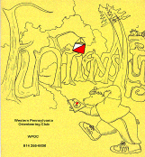
Jim Wolfe – President – (814) 255-6606 (nights)
(724) 357-6104 (days)
jlwolfe@atlanticbb.net
Bryon Roland – Vice-President – (724) 357-9328
bman66@adelphia.net
Jennifer Livingston – Secretary – (724) 770-1120
jenlivi@pobox.com

WPOC Travels: Jim and Laurie’s Tour O Swiss
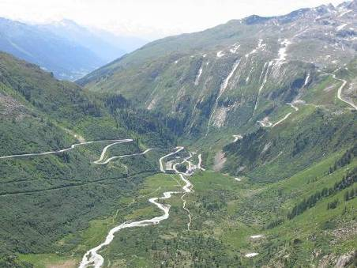
“Last July, Laurie and I went on an orienteering adventure to Switzerland. It was the second Tour O Swiss; but it was our first time on the tour – the previous one was in 2003. The orienteering federation in Switzerland organized this combined tourism and orienteering trip to give orienteers who were visiting Europe something to do between two big events. The timing of the tour was the week between the World Masters Orienteering Championships and the Swiss 6-Days of Orienteering. Laurie and I did not go to either of these big events; but we did join the Tour O Swiss, along with about 160 others from 21 different countries.
We highly recommend the Tour O Swiss for many reasons: the orienteering, the sights, the friendly people, the interesting landscape, and the price.
The orienteering meets were in very interesting areas. Some of them were on extraordinarily steep hillsides, including just below the snow line in the mountains. (The included picture is one area where we orienteered near Grindelwald.) Some were in city parks (in Davos and Lausanne) and one was in a forest very similar to those in Pennsylvania. Three of the five events we went to were traditional orienteering meets; the other two were very short events. The first one was a 15-minute score course around the streets of Davos; it used a 1:4000 scale map. This was the only rainy event we had and was naturally very fast paced; there was no time to develop a strategy – you had to keep moving and plan on the run. The other short event was a park-o event in Lausanne. In that one, I made only one error of four minutes; but that caused me to fall from the middle of the pack to last in the results.
In general, Laurie and I were at the bottom of our respective classes on the courses we ran. I pretty much expected this. Most of the participants had just come from the World Masters Championships and although they were our age, they were much faster than us. There were a lot of Australians and New Zealanders, as well as about ten Americans on the tour.
The tourism part of Tour O Swiss was quite different from what you might expect by signing up for an escorted tour to anywhere. There was no catering to the slowest in the group; everyone was expected to be fit. There were days on which we had an orienteering meet in the morning and then had an organized hike to a glacier in the afternoon or had a scheduled dinner that required a two-mile walk and a 1000 foot climb to get there. There were also days on which we were strictly tourists, riding the trains through the Alps, visiting the snow capped Jungfraujoch and the highest railway station in Europe.
The trains were very well organized; we often had several cars on the train reserved for our group – once we even had a whole train. Riding the buses was a bit more of a problem in that the roads are truly hair-raising. (See other picture.) Our guides on the tour were mostly Swiss orienteers, with only one professional tour guide involved. The guides competed at the orienteering events just like the tour group and in between events described the history, culture, and geography of Switzerland. Language was an interesting problem within the group – the guide’s spoke mostly in German, English and French; others in the group would sometimes translate this into languages such as Japanese, Norwegian, or Latvian.
It is not clear when the next Tour O Swiss may occur. The two that have taken place covered different portions of Switzerland and were organized each time to fit between big orienteering events. So, it may be two or three years until the orienteering schedule makes another Tour O Swiss likely; but, if you get a chance when the next one comes up, I think you would enjoy the experience a great deal. We certainly did.”

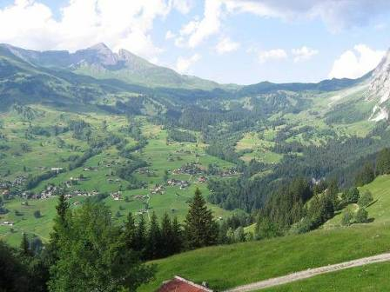

?? Question of the Newsletter – What is a collecting feature?

Event recaps:
Camp Seph Mack, 14 October 2006 - WPOC's first night orienteering meet was a spectacular success. It was a cold but clear night with a much larger than expected turnout, 49 total participants going out on the expanded score course. Bryon Roland was meet director; he designed the courses, put out the controls, cleaned up some of the paths, and took down the controls. Bryon efforts were rewarded with a large group of enthusiastic orienteers who all had a good time and many of them said so. Everyone heeded the safety briefing; so there was no need for any first aid at the finish. The only known mishap was the loss of one compass. Big thanks to Bryon for all of his work. Also, thanks to Laurie Opila for handling registration and part of the finish; thanks to Jason Livingston for helping with taking down road signs and Mary McElhinny with picking up the controls Sunday morning. The early talk is trying to have a summer night meet and coordinate it with a full moon for optimum visibility and an expanded course possibly in a different park.
The scoring system for the night course was different from our typical score courses. There were 36 controls. Those numbered 1-10 were worth 10 points each; all other controls were worth whatever their control number was (11 through 36). Penalties were -25 points per minute late.
Score Course 2 hour’s 36 controls Points and Penalties as stated above
Name | Club | Controls | Time | Penalty | Score
Kristaps Tamuzs | NEOOC | 36 | 1:39:01 | 0 | 711
Alexis Rzewski | WPOC | 32 | 1:54:45 | 0 | 663
Mary McElhinny | WPOC | 27 | 1:50:50 | 0 | 511
Jason Gray & Bill Croyle | WPOC | 24 | 1:58:39 | 0 | 495
John Hartman | WPOC | 20 | 1:54:32 | 0 | 406
Dave, Jim, & Susan |  | 17 | 1:53:05 | 0 | 320
Al Sheaffer | WPOC | 16 | 1:51:00 | 0 | 316
Jennifer Livingston | WPOC | 16 | 1:58:30 | 0 | 307
Roger Sullenberger |  | 16 | 1:54:06 | 0 | 302
Fred Mahan | BSA Troop 622 | 12 | 1:57:45 | 0 | 249
Jonathan Heider | BSA Troop 622 | 12 | 1:59:21 | 0 | 249
Josh Banyew | BSA Troop 622 | 12 | 1:59:35 | 0 | 249
Matt Bumberger |  | 11 | 2:00:32 | 0 | 222
Scouters | BSA Troop 183 | 9 | 1:50:22 | 0 | 185
Adam Steinbring - on time, lost card | BSA Troop 622 | 10 | Unknown | 0 | 181
Joe Russick | BSA Troop 670 | 7 | 1:53:30 | 0 | 166
Frank Davis | BSA Troop 670 | 7 | 1:53:30 | 0 | 166
Joe Cousins | BSA Troop 670 | 7 | 1:53:35 | 0 | 166
Wayne Richter group | BSA Troop 27 | 8 | 1:50:08 | 0 | 160
Eric Steinbring | BSA Troop 622 | 8 | 1:55:00 | 0 | 150
Jeremiah McAdams | BSA Troop 622 | 8 | 1:58:00 | 0 | 150
Rose Family |  | 5 | 1:37:28 | 0 | 103
Whatevers | BSA Troop 183 | 5 | 2:02:03 | -50 | 44
Tom Knapp |  | 2 | 1:58:13 | 0 | 39

Photos from the night meet courtesy of Jason Livingston, husband of Jennifer Livingston our club secretary.
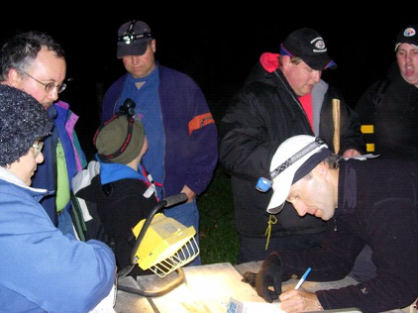

Bryon recording data 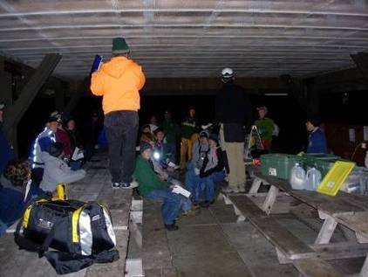
Jim giving event details

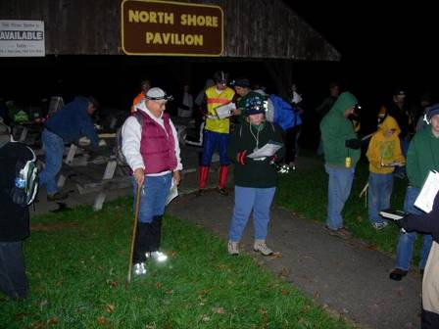
Eager competitors at the Start

Pine Ridge Park, 5 November 2006 - It was a cold day that started cloudy and got brighter as the day went on. It was good weather for orienteering. Although the map was new, it was necessary to make some adjustments because of gas well drilling - several new roads needed to be added. But John Hartman, course setter and co-director, scouted out the changes and designed some interesting courses. The turnout was unusual in that we had only one person go on the white course; but we had larger than usual turnout for both the yellow and score. We also used a new scoring system for the score in an attempt to encourage developing a strategy for attacking the course. Based on the results, the new system did what was intended. Also, a special mention goes to Ed Cabana. This was the first time he came to one of our orienteering meets; and we participated in all three courses - an impressive showing.
We welcome Jim Trautmann as a new club member. Thanks to Lenny Lewis (Sr. and Jr.), Barbara Johnstone, Laurie Opila and Karen Gracy for helping with registration. Thanks to Bryon Roland and Mary McElhinny for helping with control pickup. And thanks to John Hartman for meet directing, putting out controls and picking up controls. The spring season will begin in late March.
White Course 2.12 km 55 m climb 9 controls
Ed Cabana |  | 21:15
Yellow Course 3.05 km 125 m climb 10 controls
Alexis Rzewski | WPOC | 30:29
Mark Malagodi | WPOC | 35:53
Tim & Edna Spang |  | 47:11
Mary McElhinny | WPOC | 49:54
Ed Cabana |  | 51:36
Scott Elias |  | 58:10
McKirkan group |  | 72:30
Terry Neely |  | 78:14
Loretta Opila | WPOC | 86:17
Barbara Johnstone | WPOC | 117:21
Tammy Cash | WPOC | 137:32
Karen Gracy missed one control | WPOC | 99:54
Pinters missed one control |  | 105:51
Score Course 90 minutes 17 controls 3 x control # points/control -20 points/min late
Name | Club | Controls | Time | Penalty | Score
Bryon Roland | WPOC | All but 16 | 79:17 | 0 | 411
Alexis Rzewski | WPOC | All but 1, 2, 3, 16 | 79:26 | 0 | 393
Jerry Agin | WPOC | All but 2, 3, 8, 16 | 88:00 | 0 | 372
John Durrant | WPOC/DVOA | All but 2, 3, 14, 15 | 87:18 | 0 | 357
Jason Gray | WPOC | All but 1, 2, 3, 8, 12, 16 | 84:14 | 0 | 333
Tim & Edna Spang |  | 1, 2, 4, 6, 7, 8, 9, 10, 11, 12, 13, 14 | 86:39 | 0 | 291
Ed Cabana |  | 2, 4, 5, 9, 10, 11, 14, 15, 17 | 88:42 | 0 | 261
James Trautmann | WPOC | 2, 3, 5, 9, 10, 11, 14, 15, 16 | 90:12 | 0 | 255
Tim & Kaitlin Piper | WPOC | 1, 4, 6, 7, 8, 10, 12, 13, 15 | 89:17 | 0 | 228
Dave & Ozgur | Pitt | 1, 5, 8, 9, 10, 11, 12, 15 | 84:58 | 0 | 213
Susan Moore & Eric Rainis |  | 2, 4, 9, 10, 11, 14, 15 | 84:10 | 0 | 195
Mark Malagodi | WPOC | 4, 6, 7, 8, 11, 13 | 90:28 | 0 | 147
Answer: A collecting feature refers to large feature, like a field or pond, between you and the control you’re heading for. It should be something you can’t miss if you head in the general direction. The idea is that, if you recognize a collecting feature on a particular leg, you go as quickly as you can in that direction, paying only minimal attention to other details, once at the collecting feature, you slow down and navigate carefully to your attack point or to the control itself.
Mid Atlantic Championship:
Sunday, December 10, 2006 - McKeldin Area, Pataspco State Park - Mid-Atlantic Championships
Times:
10:00 am-1:00 pm: course Starts.
2:00 pm: Relay Mass start.
3:00 pm: Normal course participants must be off the course.
3:30 pm: Relay Participants must be off the course.
Location: McKeldin Area, Pataspco State Park
Map: McKeldin and Woodstock. 1:10,000

This is the famed Mid-Atlantic meet where all the clubs in the Mid-Atlantic can show their talent in a head to head competition. There will be the usual slate of courses White-Blue. In addition there will be the Mid-Atlantic Relays. All USOF registered Mid-Atlantic clubs are eligible: DVOA, SVO, QOC, and Western Pennsylvania. Individuals must be a member of a Mid-Atlantic club to be eligible. Individuals can only count towards one club. The scoring system allows for the disparity that can exist between large and small clubs. In fact, according to Jim, about 5 years ago, IUPOC placed second in several categories.

Complete details on the event can be found at the following: QOC - Quantico Orienteering Club serving Virginia, Maryland and District of Columbia. http://qoc.us.orienteering.org/

WE are always looking for new members and you can find the application for 2007 membership at www.wpoc.org. Thanks!

