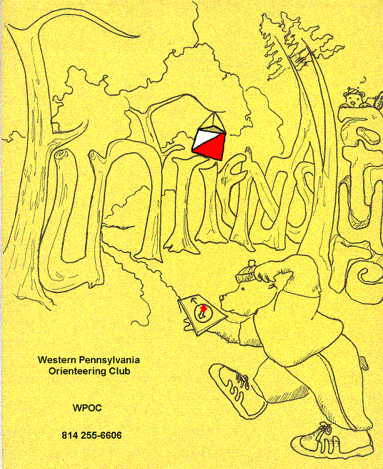
Jim Wolfe – President – (814) 255-6606 (nights)
(724) 357-6104 (days)
jlwolfe@atlanticbb.net
Bryon Roland – Vice-President – (724) 357-9328
bman66@adelphia.net
Jennifer Livingston – Secretary – (724) 770-1120
jenlivi@pobox.com

Permanent O-course at Stackhouse
There is now a permanent O-course at Stackhouse Park in Johnstown one of the few permanent courses in all of western Pennsylvania. The purpose of such a course is to provide a practice facility for orienteering and to provide a place for anyone to orienteer during times when no meets are available. The course was created under the direction of Adrienne Oldham for her Gold Award Project.
Jim Wolfe selected twenty control points. Each is marked with 4” x 4” orange and white plastic markers on metal poles cemented into the ground. Color maps showing the locations of the markers are available at the park ranger station, they are free and they will look familiar to you since they are the same ones used for our meets. The maps have the control descriptions printed on them and suggestions for three different courses, which start and finish at the ranger station. However, the twenty controls can be used like a Score course; thus, anyone may use one of the maps to practice on any subset of the controls. Also, once a person has a map, s/he does not have to start at the ranger station; there are two other park entrances with parking lots so the person can start at either of these places and choose a completely different control sequence.
You will see a link to the O-course on the website, www.wpoc.org Note: If you follow the driving directions to Stackhouse Park given on the WPOC web page (Maps & Directions link), you will enter Stackhouse Park right next to the ranger station.

?? Question of the Newsletter – What is an attack point?

WPOC Travels:
Central New York Orienteering Event – Whenever club members or non club members want to fill us in on an event that they attended please feel free to drop me a note with details about the event to be included in the next newsletter. If you are looking for an event out of state with challenging terrain and incredible maps you may want to look into attending a Central New York Orienteering Event. Bryon Roland and I competed in the 12-hour Rogaine on August 12 at the Charles E. Baker State Forest near Brookfield, NY. You could have also chosen to do the 6 hour or 24 hour events. This was the third event for their Trifecta Cup; they also hold a Snowgaine in late winter. The event was very well organized, low cost, great food, great terrain, lovely swamps, acres of briar bushes and an incredible detailed map. It was a great weekend for orienteering with mild temperatures and it was relatively easy to loop your course selection to come back to the start for food or extra clothes before dark. We represented WPOC well with a first place in not only the coed division but first place overall in the 12-hour event.

Jim and Laurie travel to Europe this past summer on an orienteering vacation and we hope to have a report from them for the next newsletter.

Event recaps:
Boyce Park Meet Recap -The first of the fall meets was held at Boyce Park on September 16, 2006. It was a very nice day for orienteering and we had a pretty good turnout. We were trying attract newcomers because it was National Orienteering Day; we did attract some newcomers, 27 by Jim’s account. Jerry Agin was meet director and he did an excellent job. Jerry created some very interesting courses. We had two white courses hoping that some of the newcomers would try the sport twice, and they did. We had a long yellow course trying to stretch those with some white experience; that seemed to well work also. And there was a fairly difficult green (difficult due to vegetation) that the advanced runners liked. Thanks to Laurie Opila, Barbara Johnstone, and Elaine Davis for running registration. Thanks to Jennifer Livingston for miscellaneous help around the registration & start. Thanks to Kristaps Tamuzs, John Hartman, and Alexis Rzweski for helping Jerry pick up the controls.
Western White Course 2.2 km 85 m climb 9 controls
Wayne Thorniley |  | 35:00
Jordan Grogan |  | 36:25
Peri Unligil |  | 36:30
Mark Kelly | BSDA - Troop 213 | 50:01
Tyler Richter, Ryan, Tyler, Jayson Tuttle | BSA - Troop 27 | 58:15
Steven Bally |  | 58:29
Pesenti family |  | 58:30
Mary Bates |  | 67:04
Greer |  | 67:20
Mark & Cole Hensley - estimated time | BSA - Troop 27 | 71:00
Emma Livingston - missing 3 controls 37:08 | WPOC | DNF
Eastern White Course 2.6 km 40 m climb 9 controls
Wayne Thorniley |  | 44:07
Jim Dunlevy | BSA - Troop 213 | 49:34
Charles Roberts |  | 54:37
Tyler, Ryan, Jayson | BSA - Troop 27 | 58:20
Mark & Cole Hensley - estimated time | BSA - Troop 27 | 60:57
Greer |  | 66:34
Livingston Clan | WPOC | 69:05
Al Merranko - missing 6 controls 69:24 | WPOC | DNF
Yellow Course 4.3 km 60 m climb 11 controls
John Hartman | WPOC | 30:44
Alexis Rzewski | WPOC | 32:44
Tim Piper | WPOC | 41:33
Smell the Roses | WPOC | 90:16
Mark & Chris Malagodi | WPOC | 111:03
Anthony Kelly |  | 117:46
Karen Gracy | WPOC | 123:05
Charles Roberts |  | 141:24
Stephen Tubbs |  | 149:22
Green Course 5.8 km 150 m climb 15 controls
Kristaps Tamuzs | NEOOC | 55:07
Alexis Rzewski | WPOC | 56:09
John Hartman | WPOC | 58:23
Brett Schwartz | HVO | 87:16
Jason Gray & Brad Thompson | WPOC | 91:35
Mark Malagodi | WPOC | 94:41
Brian & Matt Suffoletto |  | 135:01
Frances & Keith Irvin | WPOC | 141:05

Stackhouse Park Meet Recap, October 1, 2006 -It was an overcast morning and looked like it would rain at times; but it didn't. The turnout was quite low, perhaps because of the weather. We had a few newcomers, including several girl scouts. Orange was a fairly difficult course because of the amount of climb involved; green was intended to be a fast course and that is mostly how it turned out; yellow was intended to be a scenic course; but few tried it. Thanks to Laurie Opila for help with the start. Thanks to Tammy Cash, Wayne Richter, John Durrant, Karen Barrick and Katie, Abbie and Steph for helping at registration. Thanks to Mary McElhinny and Bryon Roland for helping pick up the controls. The next meet will be WPOC's first night event on October 14 at Camp Seph Mack.
White Course 1.99 km 90m climb 10 controls
Whatever | BSA Troop 183 | 32:11
183 Scouters | BSA Troop 183 | 54:21
Brad Pinter |  | 56:24
Connie Thompson |  | 60:37
Katie, Abbie & Steph | GSA | 61:42
Panthers | BSA Troop 183 | 79:41
Ryan, Tyler & Jayson | BSA Troop 27 | 81:13
Tammy Cash & family | WPOC | 81:17
Freeman & Wagner | GSA | 86:10
Yellow Course 2.96 km 120 m climb 10 controls
Tom Gray |  | 55:45
Charles Roberts |  | 77:46
Colker family |  | 154:03
Tyler, Ryan, Jayson lost punch card | BSA Troop 27 | DNF
Orange Course 4.13 km 205 m climb 13 controls
Alexis Rzweski | WPOC | 50:17
John Hartman | WPOC | 64:20
Carolyn Fisher, Mike Houdk, Pam Milavec |  | 106:51
Anthony Kelly |  | 127:20
Wayne Richter only 2 controls | WPOC | DNF
Green Course 5.33 km 140 m climb 14 controls
Alesis Rzewski | WPOC | 59:52
Bryon Roland | WPOC | 63:16
John Hartman | WPOC | 73:13
John Durrant | WPOC & DVOA | 102:27
Mary McElhinny only 10 controls | WPOC | 129:15
Charles Veit only 5 controls |  | 101:04
Fall WPOC Events:
- October 14, 2006 – Saturday- Camp Seph Mack, Night Course-mass start at 7:45 pm – Meet director, Bryon Roland
- November 5, 2006 – Sunday- Pine Ridge Park, Blairsville – 11:00 am to 2:00 pm – Co-directed by John Hartman and Jim Wolfe - White, Yellow, Score
Directions: Directions: Please check the WPOC website since the directions for all meets are posted on the web site and they are very detailed.

Night Navigation Tips and Details
What is Night Orienteering? Night orienteering is ... orienteering at night! The orienteering controls will have reflective tape on them for optimum visibility. All you will need to bring is a flashlight or headlamp, extra batteries, a compass, a whistle and your sense of Adventure!
Darkness presents its own characteristics for land navigation because of limited or no visibility. However, the techniques and principles are the same as that used for day navigation. The success in nighttime land navigation depends on rehearsals during the planning phase before the start, such as detailed analysis of the map to determine the type of terrain in which the navigation is going to take place and the predetermination of direction and distances. Night vision devices such as headlamps and/or a good flashlight can greatly enhance night navigation.

Event Details: The course will consist of 36 control points placed throughout Camp Seph and along the northern shores of Yellow Creek State Park.
- 6:30 Sign In
- 7:00 Mandatory Safety Meeting and Map Distribution
- 7:45 Mass Start, end of Twilight
- 9:45 Finish
- Bring a flashlight, extra batteries, a whistle, a compass, and something warm to wear.

Answer: An attack point is a distinct feature near a control that is easier to get to than the control itself. For instance, suppose your control is a boulder on a hillside with many boulders and that there’s a fence junction 150 meters in front of this control. Make that junction your attack point, because it should be easy to get to there. The idea is to pick out at an attack point, get there quickly, and then navigate carefully to the control.

For those WPOC members that love to orienteering and travel, listed below are some nearby Club addresses for when you looking want to have a fun weekend:
- QOC - Quantico Orienteering Club serving Virginia, Maryland and District of Columbia. http://qoc.us.orienteering.org/
- ROC - Rochester Orienteering Club – New York http://roc.us.orienteering.org
- DVOA – The Delaware Valley Orienteering Association – www.dvoa.us.orienteering.org
- NEOCC- North Eastern Ohio Orienteering Club – http://neooc.home.att.net/.
- SVO – Susquehanna Valley Orienteering, Near York, PA –
http://d-domains.net/svo/
- CNYO – Central New York Orienteering http://cnyo.us.orienteering.org/

WE are always looking for new members and you can find the application for 2007 membership at www.wpoc.org. Thanks!

