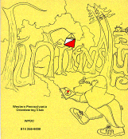
Jim Wolfe – President – (814) 255-6606
jlwolfe@atlanticbb.net
Dave Battista– Vice-President –
batty4@consolidated.net
Jennifer Livingston – Secretary – (724) 770-1120
jen.livingston@pobox.com
Club website – www.wpoc.org

Orienteering Discussion on TV thanks to Comcast

In September, Jim Wolfe was interviewed about orienteering and WPOC by Comcast Newsmakers. This cable TV program can be seen at 25 and 55 minutes past the hour on the HLN (CNN’s Headline News) channel on Comcast cable. The interview is scheduled to be aired approximately 50 times during the month of November in the Laurel Highlands Region of Comcast’s service area. This area includes all or parts of Clarion, Jefferson, Cambria, Indiana, Somerset, Bedford and Clearfield counties; it covers more than 136,000 households. It is not known which hours of the day the WPOC interview will be shown; however, the interview will not be shown between 7 pm and 2 am (HLN prime time). Nevertheless, it should be on about twice per day during the entire month.
In the interview, Jim describes what orienteering is, who participates in it and where the participation takes place. He also answers a couple questions such as, “How does geocaching differ from orienteering?” and “What are the club’s activities?” There are a lot of things that Jim could not cover regarding the club because the interview was only five minutes long, including introduction and closing.
If you are a Comcast customer in one of the counties listed above, you might want to keep an eye out for the interview. Hopefully, others who are not familiar with the sport will also see the interview and follow up with the contact information to come to some of our events.
We want to thank Comcast for providing this opportunity to introduce orienteering to the general public and to publicize WPOC and its activities.
Jim has placed a link to the interview at the club website, www.WPOC.org under the TV bullet on the front page of the website. I saw the clip on Comcast and I thought Jim did a great job in the interview explaining and promoting our sport.

A-Meet: June 25 and 26th, 2011 – Keystone Capers
June 25 and June 26, 2011 WPOC is sponsoring an A-meet called the Keystone Capers it will be held at the Keystone State Park and the Deer Lakes Park. Since an A-meet will be held at those 2 parks in 2011, no events can be scheduled at these parks in 2010. The details about the A-meet can be found at the www.wpoc.org website under the A-Meet bullet. Please contact Jim Wolfe if you are able to help with the meet the club will need participation from all its members to have a successful meet. Anyone can volunteer to help with the A-Meet you do not have to be a WPOC club member so come out and join the fun.

2011 Schedule
The tentative dates for the 2011 Spring Schedule:
- March 27, 2011 – Raccoon Creek State Park – Mini-Rogaine (3-hr and 6-hr events).
- April 10, 2011 – Hartwood Acres
- May 15, 2011 – Blue Spruce Park
- June 25 and June 26 – A-meet – Deer Lakes Park and Keystone State Park

2011 Club Dues
It is time to think about renewing your membership with WPOC for 2011. This time we are making it easier than ever. Jim Wolfe mentioned this at the meeting; but for those who were not there, WPOC now has a PayPal account. This means that you can now pay the WPOC dues online from your PayPal account or using a credit card (Visa, MasterCard, Discover) or as you did last year by sending a check through via the postal system. To pay online, go to www.wpoc.org and click on the "Membership Dues & Application" link. Your club needs You!

Event recaps:
IUP Co-Op Recreational Park – June 6, 2010
It looked like it was going to be a nasty day for orienteering; it had rained most of the night and off-and-on into the morning, until about 11:15. Even though it was fairly nice after that, many people decided earlier in the day that they didn't want to orienteer in the rain and didn't come out. Otherwise, everything went fairly well. There was one minor temporary glitch in the yellow course that was corrected - it affected only one person. Everyone else commented positively on the courses. It was Ray Wygonik's meet directing debut; and other than the low turnout, it was definitely a success.
Thanks to Loretta Opila and Dave Torick for handling registration. Thanks to Alexis Rzewski for helping with start/finish. And thanks to Dave Torick, Alexis Rzewski and a friend of Ray's for helping to pick up the controls.
White Course 2.35 km 55 m climb 8 controls
Danielle & Stacy | WPOC | 33:56
Luca Rzewski | WPOC | 48:45
Weltner Family (4) | WPOC | 68:41
Scott & Bryan Brubaker |  | 90:45

Yellow Course 3.55 km 185 m climb 8 controls
Chris Peters | WPOC | 48:53
Mary & Stacy | WPOC | 65:22
Team Chesky (3) |  | 78:32
Loretta Opila | WPOC | 119:24
Orange Course 4.75 km 205 m climb 10 controls
Mary Roland | WPOC | 64:13
Joe Logan | WPOC | 69:50
Al Sheaffer | WPOC | 109:01
Bill & Diane |  | 118:28
Tammy Cash (4) finished 8 controls in 118:55 | WPOC | DNF
Anne & Denise finished 8 controls in 128:50 | WPOC | DNF
Red Course 6.0 km 265 m climb 11 controls
Alex Rzewski | WPOC | 59:48
Jim Trautmann | WPOC | 67:08
Dan Marincel |  | 81:33
Dave Torick | WPOC | 88:08
Andrew Shissler |  | 119:39
Curt Mertz | WPOC | 120:45
Sherry Shank | WPOC | 145:36
Stackhouse Park –August 29, 2010
It was an exceptionally good day for orienteering, although it did get rather warm in the afternoon. The turnout was a little better than the last couple of Stackhouse Park meets. We managed to attract a few new faces, including a family from the Miami Valley O Club - the first we have had anyone from that club at our meets. We also had one new family join as members, Tom and Linda Gray. Welcome! Al Sheaffer, meet director, set some rather challenging courses, as evidenced by the finishing times. There was also a problem on one course - the first control on Yellow was on the wrong feature. Everyone on the yellow course still found the control; but the misplacement must have contributed to the long times.
Thanks to Bryon and Mary Roland for vetting Al's courses. Thanks to Sherry Shank, Loretta Opila, and Mary Roland for handling registration. Thanks to Barbara Johnstone for helping with start/finish. Thanks to Joe Logan and Bryon Roland for handling instruction. And thanks to Jim Trautmann, Alexis Rzewski and Joe Logan for helping to pick up the controls.
White Course 2.33 km 70 m climb 9 controls
Chris Scanga (3) |  | 50:10
Anita, Luca & Giuseppina | WPOC | 57:23
Caterina & Emily | MVOC | 66:50
Rebecca, Attillo, Barb & Mark |  | 72:05
Gary Baumgardner (2) |  | 92:18
Rodger & Cindy Holsing |  | 96:28
Lee & Hunter Bash |  | 103:36
YAIH (4) |  | 111:45

Yellow Course 3.78 km 140 m climb 9 controls
Dave Battista | WPOC | 52:39
Adam Hodges |  | 83:35
Luca Rzewski | WPOC | 84:08
Joan Ferraro | WPOC | 105:02
Venture Crew Leaders (4) |  | 114:09
Loretta Opila | WPOC | 143:57
Barbara Johnstone | WPOC | 161:45
Molchany (3) |  | 162:00
Orange Course 4.40 km 225 m climb 12 controls
Alexis Rzewski | WPOC | 51:49
Sherry Shank | WPOC | 136:07
Pinters (3) No punch card; not checked |  | 211:20
David Ross missed control #9 152:35 |  | DSQ
Redskulls (3) found only first 6 controls 176:55 |  | DNF
Green Course 5.15 km 285 m climb 12 controls
Alex Rzewski | WPOC | 62:49
Tom Svobodny | MVOC | 65:56
Jim Trautmann | WPOC | 76:57
Joe Logan | WPOC | 123:13
Frank Ferraro | WPOC | 132:33
Tom & Linda Gray | WPOC | 147:48
Adam Hodges |  | 163:46
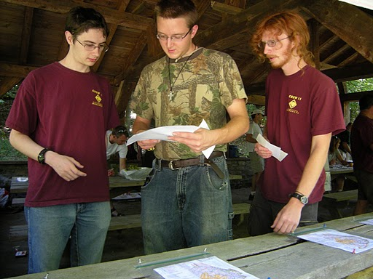
Picking a map
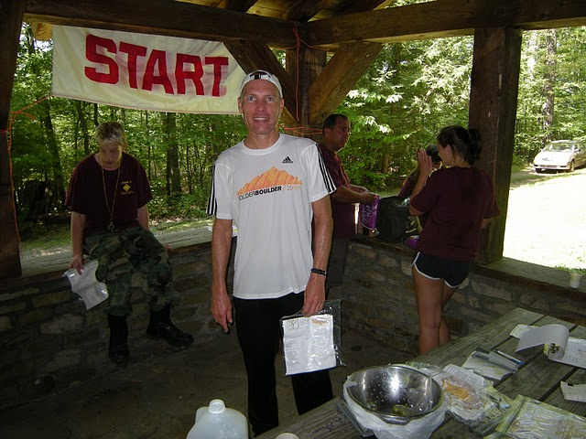
Happy Finisher!
Camp Twin Echo – September 19, 2010
It was a partly sunny day and by mid-afternoon the temperature reached into the 70's. It turned out to be an excellent day for orienteering. The only complaint that I heard was about the bugs; there were approximately one billion gnats in residence around the registration/start area.
This was our National Orienteering Day event and we tried to attract as many newcomers as we could. We seemed to have done a pretty good job as we had a lot of participation on our beginning courses and a lot of action in the instruction areas. We provided two White courses and some of the newcomers tried both of them; this was what we had hoped would happen. Others tried a White and then a Yellow course; those who did found the yellow a much harder course.
We had two courses that we don't offer at most of our meets. We had a Brown course - the shortest version of a course that requires expert skills. It was only 3.91 km long but provided some interesting challenges judging by the finishing times. We also had a Line course - participants had to follow a 4.8 km twisting and turning line and find the controls that were on the line (they were not marked on the map). This proved to be a fairly difficult task as no one found all the controls on the line. A time penalty system was used for controls that were missed on the course. It would have been good to have a few more participants on the Brown and Line courses, although we did attract one person from SLOC (I'm not quite sure how).
We also added one new membership at the meet. The Holsing's have joined the club; welcome Rodger and Candy. And congratulations to our three door prize winners: Demaund Copeland, Tom Gray, and Matthew Mosteller. Prizes courtesy of Orienteering USA.
Jim Wolfe was meet director. Thanks to Ray Wygonik, Mary Roland, Jennifer Livingston and Laurie Opila for running Registration. Thanks to Sherry Shank, Dave Torick, and Ray Wygonik for handling start/finish. Thanks to Joe Logan and Bryon Roland for doing instruction. And thanks to Jennifer Livingston, Dave Torick and Alexis Rzewski for helping with control pickup.
White East Course 2.44 km 10 controls
Troop 375 Ligonier (7) | BSA | 38:00
Luca Rzewski | WPOC | 40:05
Troop 183 Dads (2) | BSA | 51:20
Emma Livingston (2) | WPOC | 61:50
Boy Scouts (5) | BSA | 62:43
Cole Frederick | BSA | 73:50
Xtream Team (6) |  | 73:55
Troop 183 Serpents (6) | BSA | 83:30
The Jones' (2) |  | 94:30
Pribanic (4) allowed only to do 5 controls 28:20 |  | DNF
White West Course 2.50 km 10 controls
AG 2 (3) | Gallatin | 47:57
Mina & Magiur Birkeland | FANA | 53:29
Boy Scouts (5) | BSA | 62:50
AG 1 (3) | Gallatin | 73:54
Emma Livingston (2) | WPOC | 77:50
Extreme Team (6) |  | 86:35
Hiro Stone (2) | Pack 40 | 88:33
Mark Gaydos (5) | Pack 40 | 89:37
Opferman (5) |  | 106:44
Rodger & Candy Holsing | WPOC | 122:05
Yellow Course 3.49 km 10 controls
Kari Fladmark | FANA | 36:00
AG 2 (3) | Gallatin | 103:20
Anne & Kathy | WPOC | 112:30
Christel Turungan & Sarah Popiel | IUP | 116:30
Abby Shaw & Deirdre Bruno | IUP | 118:30
Allie Nunn & Melissa Zehe | IUP | 120:30
Trail Blazers (3) missed controls #8 and #10 140:55 | Gallatin | DNF
Kimi Kozak & Erica Panick found only control #1 | IUP | DNF
Brown Course 3.91 km 10 controls
Dave Torick | WPOC | 70:21
Joe Logan | WPOC | 74:34
Dan Marincel | SLOC | 85:33
Sherry Shank | WPOC | 96:27
David Ross |  | 175:28
Barbara Johnstone | WPOC | 209:10
Jim Trautmann found only 4 controls | WPOC | DNF

Line Course 14 controls (about 4.8 km) 10 minute penalty for each missed control up to five
Name | Club | Missed | Return | Penalty | Total Time
Jim Trautmann | WPOC | 1 | 103:03 | 10:00 | 113:03
Alexis Rzewski - second try forwards | WPOC | 5 | 130:50 | 50:00 | 180:50
Chris Scanga |  | 3 | 189:30 | 30:00 | 219:30
Tom & Linda Gray & Dan Bigart | WPOC | 1 | 236:12 | 10:00 | 246:12
Alexis & Luca Rzewski backward | WPOC | 8 | 85:48 | DSQ | DSQ
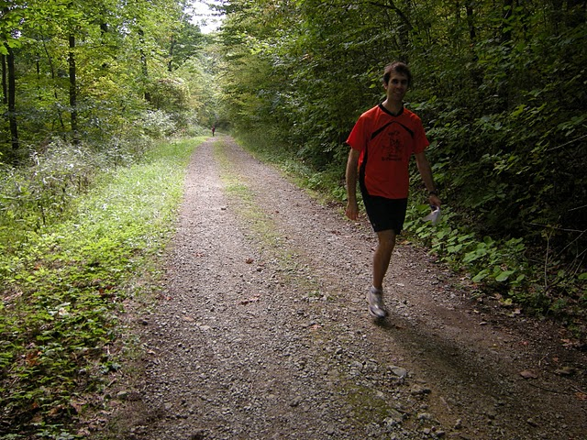
Orienteering Fun and Great Exercise!
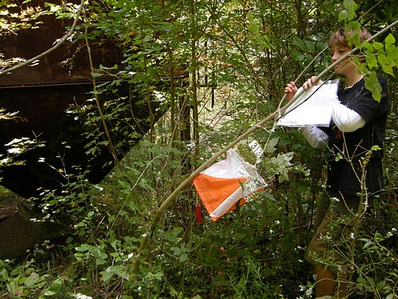
Fun for all ages
Boyce Park – October 3, 2010
It was a dreary day, looking like it could rain at any moment. In fact, it did rain starting about 2 pm. The temperature held steady at 50. Nevertheless, we had an extraordinary turnout with 74 starts and about 175 people going out on courses. Both of these are new record highs for the club. There were a lot of newcomers; at one time, I think there were three simultaneous instruction sessions going on. We ran out of maps for two of the courses - yellow right at the end of registration and orange much earlier. All the comments that I heard were very positive, even from those competitors on orange or the scramble who came back with hundreds of burrs attached.
Dave Battista was meet director. Based on the winning times, his courses were right on target. However, many competitors found the courses quite long, especially the orange course. This was because some were trying to move up to the orange course (always a big leap from yellow) and others, who were trying orienteering for the first time, insisted on beginning with orange. As the results show, quite a few in the latter category did not fare well. This was the second time we have offered a scramble course; there was a lot of good feedback about it; we will be offering it again in the future. A half-scramble was also offered - just do the first half of the scramble. It turned out to be a very successful meet.
Several new members were acquired at the meet. Welcome to Dan Marincel, Patrick Hickey, and Dana Dolfi. We also had a couple of previous members rejoin the ranks. Welcome back to Lori Yost and K Villowock.
Thanks to Barbara Johnstone, Alexis Rzewski, Laurie Opila, and Dave Torick for handling registration. Thanks to Sherry Shank for handling start/finish. Thanks to Joe Logan, Laurie Opila for conducting instruction. Thanks to Mike Adametz for drawing more Orange Course maps after we ran out. And thanks to Dave Torick, Alexis Rzewski and Mike Adametz for helping to pick up the controls.
White Course 2.2 km 60 m climb 8 controls
Mina & Magne Birkeland | FANA | 34:01
Luca Rzewski | WPOC | 41:41
Spartans (5) | JROTC | 52:17
Team Bravo (6) | JROTC | 52:22
Mel Hainey (3) |  | 54:37
Land Nav 1 (6) | JROTC | 54:42
Zachary Buell (2) |  | 55:54
Renee Dolnay (3) |  | 59:00
Jacob Majors & Matt Sedlak (4) |  | 66:26
Matthew Price (2) |  | 66:42
Ethan West (2) |  | 72:55
Troop 184 (5) | BSA | 76:01
Franks (4) |  | 84:15
Opferman (5) | Pack 40 | 84:36
Troop 5 (7) | BSA | 94:10
Darlene Clark (3) |  | 97:45
Girl Scout Troop 50134 (13) | GSA | 100:00
Jones' (2) |  | 104:52
Cody Tworek & Mark Stanchik (4) | Pack 40 | 117:50
Tom Kaveney (3) Found first 4 controls; no official start |  | DNS

Yellow Course 3.4 km 105 m climb 9 controls
Patrick Hickey | WPOC | 46:47
Lori & Julia |  | 66:45
Roger Stoffregen |  | 71:20
Frances Irvin, Keith, Ian |  | 72:45
AG 2 (3) | JROTC | 74:08
Mike Adametz | WPOC | 77:38
K. Villwock (3) | WPOC | 77:40
Team AG (6) | JROTC | 99:50
Cole & Alexis |  | 113:55
Spartans (7) | JROTC | 115:00
Smell the Roses (2) | WPOC | 116:05
Cole Frederick | BSA | 117:50
Huber, Ashcom & Davidoff | SciTech | 129:00
Klimek (4) |  | 140:58
Band of Brothers (3) | JROTC | 147:57
Ryan & Tyler Gaydos, Hiromi Stone (9) |  | 163:10
Team Slowpokes (2) No official Start; completed the course |  | DNS
Orange Course 4.9 km 180 m climb 9 controls
Kari Fladmark | FANA | 63:06
Eric & Karl | CMU | 86:14
Johan Holm | EIF | 95:35
Lori & Julia |  | 119:36
Martha Gray & Matt Janick |  | 128:16
Ken Lappin | NEOOC | 133:40
Tommy Liu | CMU | 133:45
Sherry Shank | WPOC | 136:55
Aaditya Ramdas | CMU | 145:50
Troop 78 Leaders (3) | BSA | 154:30
Trekin' Teachers (3) |  | 166:40
David Ross |  | 167:45
Troop 78 Scouts (3) | BSA | 182:00
Ken Janowitz Family (4) |  | 228:30
Tiffany Ng missed controls 6 & 7; 182:00 | CMU | DSQ
Lane Kurkjian missed last three controls; 163:25 | CMU | DNF
Nathan Brooks missed last three controls; 180:00 | CMU | DNF
Zang Qi & Amanda Michael missed last three controls; 217:00 | CMU | DNF
Cong Lu & Shuang Yan Xiong missed last three controls; 219:00 | CMU | DNF
Joan Ferraro missed last three controls: 241:48 | WPOC | DNF
Disorienteers I (6) found only first four controls; 127:38 |  | DNF
Prashant Sridhar found only first three controls; 158:45 | CMU | DNF
Li Li & Xuan Liu did not return to finish | CMU | DSQ
Half Scramble 4.8 km about 185 m climb 9 controls
Joe Logan | WPOC | 89:50
Scramble Course 7.0 km about 355 m climb 17 controls
Alexis Rzewski | WPOC | 76:24
Andy Strat | QOC | 79:50
Randy Mitchell | NEOOC | 103:00
Dan Marincel | WPOC | 105:35
Dave Torick | WPOC | 106:00
John Rasinski | NEOOC | 116:30
Eli Fatsi | CMU | 124:40
Frank Ferraro | WPOC | 151:00
Jason Koenig | CMU | 151:55
Jason Gray | WPOC | 156:50
Mike & Diane Lorenz | WPOC | 165:00
Bonnie Hartmann missed three controls; 164:15 | NEOOC | DSQ
Fedya Kleshchev stopped after control #10; 76:12 | CMU | DNF
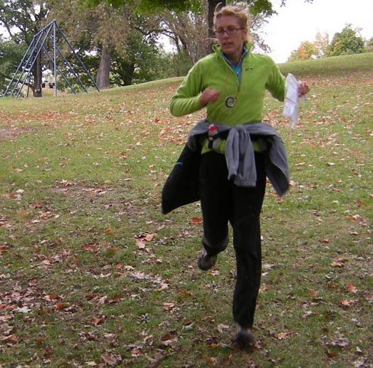
Speedy Finishers!

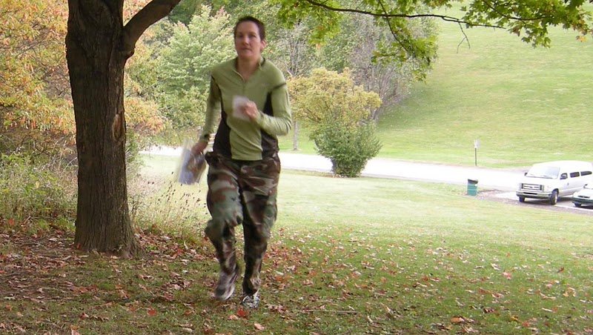

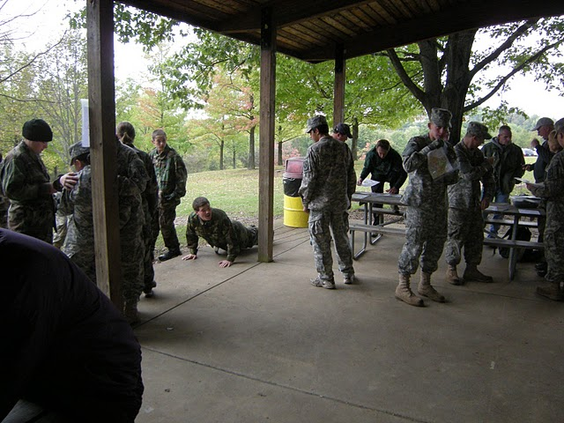
Sharing the Fun with Friends
Pine Ridge Park, November 14, 2010
Although the day started out sunny, it soon clouded up and from about 11 am on there was a very light, nuisance rain. The temperature stayed in the low 50's; so the conditions were not that bad. We had a good turnout with many newcomers; there were a total of 41 starts. There were a higher than expected number on the white and yellow courses, mostly thanks to the number of boy scouts participating.
The winning time on the white course was under 17 minutes! Josh Cumberland is clearly a runner who knows how to orienteer. The times for the yellow course were a bit long, as expected - it went up over the mountain, down the other side and back again. Quite a few people found all 18 controls on the score course in under 90 minutes; but Toby Angove set the pace as usual with just over one hour. Bryon Roland was the meet director and course setter; I heard several very positive comments about the courses, especially the score course. Bryon also put in a short stint as animal control officer in dealing with a sick squirrel prior to the start of the day's activities.
Thanks to Barbara Johnstone, Laurie Opila, Dave Torick and Ray Wygonik for running registration. Thanks to Sherry Shank & Mary Roland for running start/finish. Thanks to Dave Battista, Jim Trautmann and Alexis Rzewski for helping with control pick up. Also, thanks to Laurie Opila for managing the pot luck dinner.
White Course 2.06 km 8 controls
Josh Cumberland | ECP | 16:50
Luca Rzewski (2) | WPOC | 33:30
Tom Patterson |  | 43:22
Mike Strane, Seth Keller, Fred Guthrie, Kyle Neimayer, James Modon | BSA 269 | 51:55
Deb Skander, David & Brian Pickford |  | 58:10
The Jones' (3) |  | 60:00
Emma Livingston (2) | WPOC | 65:30
David Hurst, Tom & Linda Gray | WPOC | 66:30
Anthony, Andrew & Rachel Polka |  | 80:30
Mark, Ryan & Tyler Gaydos and William Klink | Pack 40 | 81:20
Andrew Crampton missed last control; time: 25:50 | ECP | DNF
Yellow Course 3.55 km 10 controls
Erin Rycroft |  | 52:05
Breanne & Toby Angove |  | 55:53
Josh Cumberland & Andy Crampton | ECP | 62:45
Danielle Morse |  | 63:00
Scott Pendleton & Jody Keller | BSA 269 | 66:48
Jeff Maurin & Matt Janick | ECP | 87:30
Joan Ferraro |  | 79:31
Giuseppina Mecchia (3) | WPOC | 89:21
Kim & Chris Mamula | ECP | 90:30
Barbara Johnstone | WPOC | 92:45
Lisa Storey & Tina Castillo | ECP | 109:00
Fred & Andy Chenot |  | 111:30
Jamie & Erin | ECP | 113:45

Score Course 90 minutes 18 controls 10 points per control 20 point penalty per minute late
Name | Club | Controls | Time | Penalty | Score
Toby Angove |  | 18 | 61:30 | 0 | 180
Alexis Rzewski | WPOC | 18 | 73:30 | 0 | 180
Andy Strat | QOC | 18 | 81:30 | 0 | 180
Dave Battista | WPOC | 18 | 86:45 | 0 | 180
Thomas Rycroft |  | 18 | 89:30 | 0 | 180
Danielle & Mary | WPOC | 14 | 85:27 | 0 | 140
Curtis Mertz | WPOC | 12 | 79:00 | 0 | 120
Joe Logan | WPOC | 12 | 84:00 | 0 | 120
Sherry Shank | WPOC | 9 | 83:20 | 0 | 90
Fedor Kleshchev & Zari Salimnejad |  | 9 | 84:15 | 0 | 90
Andrew Jamison (2) |  | 9 | 84:30 | 0 | 90
Dave Torick | WPOC | 13 | 92:00 | -40 | 90
Ken Lappin | NEOOC | 6 | 85:30 | 0 | 60
Tom & Linda Gray | WPOC | 6 | 85:45 | 0 | 60
Jim & Gail Trautmann | WPOC | 6 | 87:30 | 0 | 60
Ray Wygonik | WPOC | 12 | 94:38 | -100 | 20
Brian, Becky & Kevin Manley | WPOC | 6 | 116:40 | -540 | -480

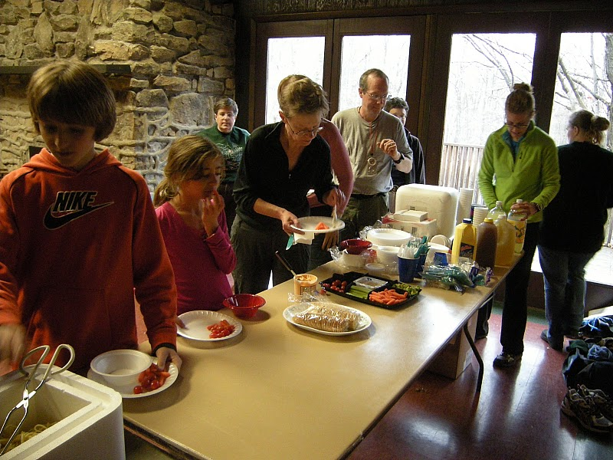
Hungry Orienteer’s
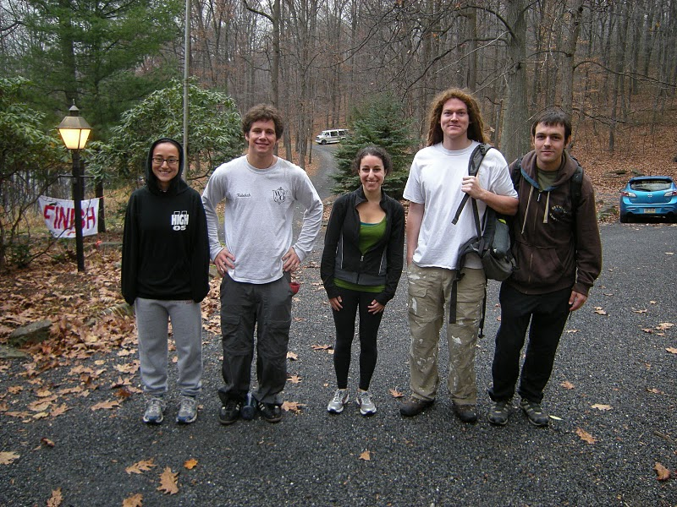
Fun on a Fall Day!
** Photos in the newsletter – Most of the photos found in our newsletter are taken by Alexis Rzewski, thanks Alexis.
Short Map and Compass Work at Raccoon State Park, Sunday, Nov. 21, 2010
There is an event called “Lost Proofing” being held at the Raccoon State Park on Sunday, November 21, 20101 from 2:00 to 3:30 pm. The description of the event is as follows, “Worried about getting lost in the woods? This program will cover a variety of skills to keep you aware and comfortable in the outdoors. We'll cover basic map reading, using a compass, why humans walk in circles, lost person behavior, natural indicators of direction and other methods of "keeping you strait". Meet at the Parks Wildflower Reserve Nature Center on Route”30.” The link below gives the details.
http://www.dcnr.state.pa.us/Calendar/view_event.asp?CalendarID=17359&Location=List
Alexis Rzewski’s creative handout to promote the sport!
