
Jim Wolfe – President – (814) 255-6606
jlwolfe@atlanticbb.net
Bryon Roland – Vice-President – (724) 357-9328
bmann66@comcast.net
Jennifer Livingston – Secretary – (724) 770-1120
jen.livingston@pobox.com
Club website – www.wpoc.org

Happy Holidays
We hope everyone has a happy, healthy and safe holiday.

2010 Schedule
The schedule for WPOC events for 2010 may be available on the club website by mid to late January. Jim has a very full schedule planned and preparation has begun for the “A” meet scheduled for late June, 2011 at Keystone ST and Deer Lakes Park.
Jim is looking for meet directors for the 8 possible meets, with the possible addition of one new map, so drop him a line if you want to volunteer to be a meet director.

2010 Club Dues
If you haven’t already, now would be a great time to renew your club membership for 2010. The membership application is available at www.wpoc.org

Orienteering in Schools and College Development, request from USOF
Note from Donna Fluegel, secretary of USOF and editor of ONA. Who is also in charge of the programs to get Orienteering in Schools and College Development.
“O in Schools is geared towards elementary thru high school age students. I'm looking for people to help with getting orienteering into the schools across the country. Yes, that's right, every school, in every state. It could be part of gym class or math class or an after-school club. I know there are many of you who have already done this in your local communities, but we need to share this information across the USOF community so we're not reinventing the wheel with each school. If you have school-age kids or work in a school, I especially need to hear from you. You already have contacts in the schools.
For College Development, this involves getting orienteering clubs started in colleges. This may be a bit more difficult, but hey, so is orienteering at times, and you know we all love a challenge. Teach college? You're my man or woman! Face it, having West Point win the Intercollegiates every year is getting a bit old, don't you think?
So, give me a yell. Really, take the plunge and get more involved in promoting the sport in the schools and helping our new Executive Director, Glen Schorr, in his goal of not always having to explain what he does for a living (come on, aren't you a little tired of hearing, "you do what on the weekends?")
Just send me an e-mail and I'll let you know what's happening!
Donna Fluegel fluegeldonna@sbcglobal.net “

Event recaps:
Keystone State Park, August 16, 2009
It was a very hot day to be orienteering (mid 80's). The vegetation was at its height and that included the poison ivy. The turnout was fairly good, light for the White and Yellow courses but ok for Orange and Green. We had several people show up who had not been to our meets before, most notably Lori & Julia who went out on three courses. Jennifer Livingston was meet director and course designer. There were a lot of positive comments about the courses, except perhaps for Orange. Jim Wolfe, who printed the maps, made a mistake and left one control off of the pre-printed Orange maps. This caused a little problem for the first few people out on Orange; but a correction was made in time for most Orange competitors.
We had one new member join at the meet; welcome to Martha Heselbarth.
Thanks to Michael Adametz, Dave Torick and Mary McElhinny for handling registration. Thanks to Joe Logan and Bryon Roland for covering start/finish. And thanks to Dave Torick, Dave Battista and Michael Adametz for helping to pick up the controls.
White Course 2.25 km 40 m climb 7 controls
Lori & Julia |  | 24:25
Corvatto Family (10) |  | 38:00
Deb Skander + David & Brian |  | 67:22
Emelia PJCC (4) |  | 68:32
Young Family (4) mispunched on one control (58:52) |  | DSQ
Yellow Course 3.6 km 130 m climb 9 controls
Mary McElhinny | WPOC | 50:10
Eric Jnah |  | 69:00
Lori & Julia |  | 76:27
Joan Ferraro | WPOC | 93:46
K & J Janowitz |  | 97:50
Michael & Zach Ward | WPOC | 102:20
Anne, Dave & Marv |  | 108:00
Steve Sarver |  | 108:10
Joe, Angela & Joshua Weltner | WPOC | 118:29
Orange Course 4.3 km 140 m climb 9 controls
Dave Torick | WPOC | 53:58
Tim Piper | WPOC | 70:30
Lori & Julia |  | 81:41
Loretta Opila | WPOC | 128:41
Jason Maruccio | WPOC | 182:10
Barbara Johnstone | WPOC | 186:10
Green Course 5.7 km 185 m climb 10 controls
Bryon Roland | WPOC | 73:24
Dave Torick | WPOC | 81:00
Jim & Matt |  | 94:30
Dave Battista | WPOC | 95:10
Dan, Mark & Sonya |  | 99:08
Rob Wilkison | DVOA | 100:40
Andrew Shissler |  | 103:43
Joe Logan | WPOC | 104:30
Frank Ferraro | WPOC | 107:05
Eric Jnah |  | 108:25
Jason Gray | WPOC | 120:06
Michael Adametz | WPOC | 142:22

Blue Spruce Park, September 20, 2009
It was an ideal day for a National Orienteering Day event; the only things that were missing were the participants. For whatever reasons we had a low turnout, considering the weather, the fact that we were giving away stuff and the lateness of the Steelers game. This event was also co-sponsored by the Friends of the Park; however, only a couple of them showed up. Most of those who came had a good time. There was a little unexpected problem for those on the Orange course - one of the controls was incorrectly circled on the maps. Nevertheless, everyone who went out on Orange actually found the control. Bryon Roland was the meet director; but the error on the Orange course control was not his fault. Jim Wolfe incorrectly drew the Orange maps.
Thanks to Patricia Ward, Barbara Johnstone, Mary McElhinny for handling registration. Thanks to Loretta Opila for providing instruction. Thanks to Joe Logan and Alexis Rzewski for handling start/finish. And thanks to Mary McElhinny, Bryon Roland and Alexis Rzewski for helping to pick up the controls.

White Course 1.67 km 45 m climb 8 controls
Luca Rzewski | WPOC | 37:38
Teresa & Dylan Rinehart |  | 48:06
Team Cash-Wright (8) |  | 49:30
Terry & Bob Chesky |  | 51:08
Michael Glasser (2) | Troop 29 | 51:18
Friends of the Park (3) |  | 54:05
Emma & Katrina | WPOC | 62:05
Maureen Paskar & Pat Ronczka |  | 74:55
Yellow Course 3.2 km 60 m climb 9 controls
Team Sherman (2) | WPOC | 39:49
Thomas Latoza & M.C. Tschantz | CMU | 52:34
Terry & Bob Chesky |  | 87:22
Giuseppina Rzewski (3) | WPOC | 89:33
Barbara Johnstone completed 5 controls 77:51 | WPOC | DNF
Emelia PJCC (3) completed 5 controls 82:01 |  | DNF
Orange Course 4.7 km 170 m climb 12 controls
Caleb & Mary | WPOC | 77:20
Tschantz & Latoza | CMU | 97:40
Chris, Ally & Olivia Peters missed control #3 118:19 | WPOC | DSQ
Loretta Opila mispunch & missed 2 controls 175:00 | WPOC | DSQ
Red Course 7.4 km 270 m climb 22 controls
Toby Angove |  | 70:32
Alexis Rzewski | WPOC | 83:43
Fedya Kleshchev | ORCA | 96:22
Jason Gray | WPOC | 131:53
Ethan Goldblum |  | 137:25
Jim Hokanson & Matt Perich |  | 139:13
Joe Logan | WPOC | 150:20
Frank & Joan Ferraro | WPOC | 184:28

Deer Lakes Park, October 4, 2009
It was a rather overcast day with the temperature in the high 50's; but it didn't rain. We had a large turnout with a lot of newbies; in fact, we ran out of White course maps at the end and had to copy one. But many White course participants were treated to an encounter with an unusual non-competitor that positioned himself on the most obvious route between controls #1 and #2 - a large beaver. Many of the novices clearly had a good time and said they would come to our events again.
Dave Battista was meet director. Based on the finishing times, his courses were quite challenging. This was the first event in which we offered a scramble format course; it turned out to be a bit too difficult as several competitors finished with times close to or over 3 hours. A half-scramble was also offered - just do the first half of the scramble. One control (d) was complained about by many competitors; in hindsight, it probably shouldn't have been used because of the thickness of the vegetation surrounding it. Many of the scramble (and half-scramble) competitors did not follow the punching instructions which said, "The clue sheet associates the numbers 4 5 6 and 7 with [the boxed] controls ... to show where you should punch for the controls on the punch card." Instead, several competitors seemed to punch the boxed controls in the order they visited them. These competitors are marked with an asterisk in the results and would technically be disqualified; but because this is the first scramble, their punches were accepted.
Jennifer Livingston set up a string-O course for the younger children. A number of them did the course before or after spending some time on the swing set and/or going out with their parents on a regular course.
We had one new person join; Brittany Breier became our first junior member - welcome Brittany.
Thanks to Dave Torick, Brittany Breier, Janice Shields, Jason Maruccio, Alexis Rzewski, Jen Livingston and Loretta Opila for handling registration. Thanks to Joe Logan and Terry Gillis for handling start/finish. And thanks to Paul Sutcliffe, Joe Logan and Alexis Rzewski for helping to pick up the controls.
White Course 1.7 km 40 m climb 9 controls
Jesse & Donna Loatman |  | 30:26
Jackson Perry | Indian Guides | 30:40
Luca Rzewski | WPOC | 32:00
Katrina & Emma | WPOC | 49:00
Beegle (2) |  | 50:22
Lamisons (3) |  | 54:09
Ron Becher |  | 54:37
Kukieza Family (4) |  | 55:10
Rose (3) |  | 55:14
Heather Young (4) |  | 58:20
Ritter (2) |  | 58:20
Steelers (4) |  | 58:50
Hugh & Hugh (4) |  | 58:55
Dennis & Jordan |  | 59:40
Doug & Nolan (3) |  | 60:47
River Icenhour (4) | Troop 495 | 76:00
Shea & Pahri Cullen |  | 76:28
Greiner (2) |  | 77:15
Blue Jays & theScorpion (4) |  | 79:22
Battista Family (3) |  | 80:25
Todd Turner (3) |  | 81:50
Stacy Bell (3) |  | 84:53
John Barnett (3) |  | 85:33
The Breier Bunch | WPOC | 87:35
Yellow Course 2.75 km 80 m climb 10 controls
Matteo Pesenti (2) |  | 65:13
Patty Murtha |  | 68:36
Giuseppina Mecchia (2) | WPOC | 75:53
Augustine (2) | WPOC | 83:30
Dave Matlin & Rachel Bieber |  | 83:55
Riley Lamison & Jarek (4) |  | 89:47
Steelers (4) |  | 92:07
Flaming Mongoose (4) |  | 111:26
Chesky (4) |  | 111:53
Phoenix Group (5) |  | 112:46
Alpha Wolf (4) |  | 114:15
Tuscan Raiders | WPOC | 122:37
Orange Course 3.7 km 150 m climb 9 controls
Joe Logan | WPOC | 81:51
Paul & Kathy Sutcliffe | WPOC | 91:36
Jason Maruccio | WPOC | 92:53
Luca Rzewski (2) | WPOC | 94:22
Andrew Shissler & Steve Thomas |  | 98:42
Tim, Nathan, Ryan | WPOC | 104:36
Ian, Keith, Frances Irvin |  | 115:48
Loretta Opila | WPOC | 119:57
James Tremblay |  | 123:20
Joan Ferraro | WPOC | 135:10
Roger Stoffregen found 5 controls in 67:37 |  | DNF
Half Scramble 4.5 km about 250 m climb 9 controls
Mark Desnoyer * |  | 88:54
Thomas Latoza * | CMU | 173:50
M.C. Tschantz * | CMU | 175:50
Terry Gillis found 8 controls in 190:27 * | WPOC | DNF
Scramble Course 8.4 km about 450 m climb 16 controls
Alexis Rzewski * | WPOC | 95:28
Jim Troutmann * | WPOC | 132:18
Fedya Kleshchev | ORCA | 145:21
Mike & Diana Lorenz | WPOC | 171:10
Frank Ferraro | WPOC | 172:43
Ethan Goldblum | CMU | 185:56
Samarth Bhargara | CMU | 185:56
John Hinderliter * | WPOC | 226:44
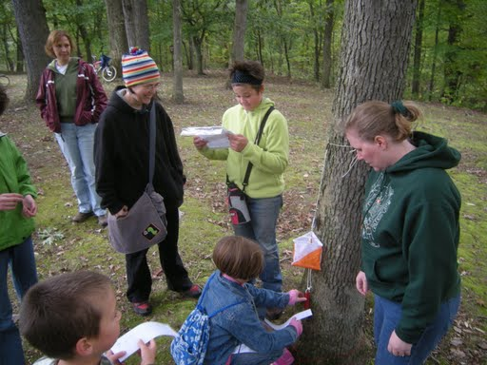String O Fun
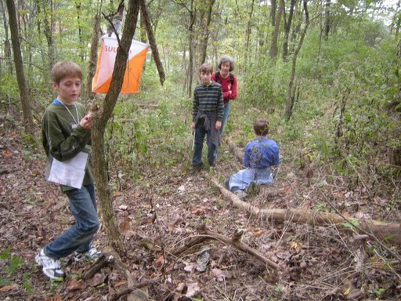Having fun at Deer Lakes
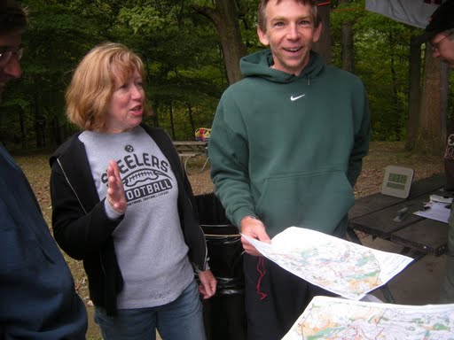
Happy Meet Director at Deer Lakes

Camp Seph Mack, October 24, 2009
WPOC's fourth night orienteering meet was our first fall night meet in three years. It had rained much of the previous day and night; so everything was wet and muddy; but we didn't get any noticeable rain during the meet. The temperature was in the low 50's with a 10-20 mph wind. Orienteering conditions were pretty good. The map was a new expanded revision of the Camp Seph Mack area, adding about 1 km more shore line and converting to more standard form, including 5 m contours.
The scoring system for the night course was different from our typical score courses. There were 40 controls. Four of them were worth 5 points each; 23 were worth 10 points; and 13 were worth 15 points for a total of 445 possible points. There was a 10 point per whole minute penalty for each minute late. Each punch card is listed separately in the standings below, even if some people went on the course in a group. The times and scores should make it clear who went together. Al Sheaffer, meet director, designed the course so that the 15-point controls were in the most remote reaches of the map. Controls were placed over more than 2 miles of the north shore of Yellow Creek SP. I thought that Al had done a very good job of distributing the controls and that it would be very difficult for anyone to get all of the controls in the 150 minutes.
Alexis Rzewski came very close to getting all controls; he missed one and was a few minutes late. Ironically, the one control he missed (#14) was visited by all but four other competitors. No control was visited by every orienteer; probably #4 came the closest with all but two competitors visiting it. Every control was visited by at least three orienteers; naturally, the ones far to the east had the fewest visitors. Also, the only competitors who visited any of the 15-point controls were Ruth Isaacson & Jason Munley and the people who scored 175 or more points. A fair number of the scouts and leaders did not try to stay out the whole 2 1/2 hours; they returned early but still turned in quite respectable scores.
We had one sort-of new person join the club. Rob Cooney, who had been a member a few years ago, rejoined. Welcome back Rob. Thanks to Laurie Opila for helping with registration, as well as providing cookiies and some very welcome hot chocolate. Also, thanks to Bryon Roland and Mary Roland for helping with control pick up.
Night-O Score Course 2 1/2 hours 40 controls Points as stated above
Name | Club | Controls | Time | Penalty | Score
Alexis Rzewski | WPOC | 39 | 2:34:44 | -40 | 400
Dave Battista & Matt McCusker | WPOC | 28 | 2:24:16 |  | 320
Rob Cooney | WPOC | 25 | 2:25:14 |  | 285
Jim Hokanson, Matt Perich, Chris Ayers |  | 23 | 2:28:14 |  | 230
Ethan Goldblum | CMU | 24 | 2:34:25 | -40 | 205
Grant Skudlarek | CMU | 23 | 2:34:25 | -40 | 200
Dan Bigart |  | 18 | 2:17:52 |  | 175
Linda & Tom Gray | WPOC | 18 | 2:17:52 |  | 175
John Motto |  | 18 | 2:17:52 |  | 175
Joe Logan | WPOC | 17 | 2:07:53 |  | 150
Michael Adametz | WPOC | 16 | 2:20:30 |  | 140
Terry Gillis | WPOC | 13 | 1:47:08 |  | 120
Andy Roethlein |  | 13 | 1:47:08 |  | 120
Dan Zimmer |  | 13 | 1:47:08 |  | 120
Joe & Josh Weltner | WPOC | 13 | 2:11:50 |  | 120
Becky Krupa | Venture | 11 | 2:25:38 |  | 115
Eric Steinbring | WPOC | 11 | 2:25:38 |  | 115
Sarah Krupa | Venture | 11 | 2:26:23 |  | 115
Adam Steinbring | Venture | 11 | 2:26:23 |  | 115
Zachory Vrabel | Venture | 11 | 2:26:23 |  | 115
Chris Gillis | BSA | 12 | 1:50:04 |  | 100
Benjamin Harris | BSA | 12 | 1:50:04 |  | 100
Matt Roethlein | BSA | 12 | 1:50:04 |  | 100
Zack Zimmer | BSA | 12 | 1:50:04 |  | 100
Thomas Krill | BSA | 10 | 1:34:54 |  | 90
Ruth Isaacson & Jason Munley |  | 6 | 2:25:22 |  | 65
Luca Rzewski | WPOC | 4 | 1:12:23 |  | 25
Mitchell Doerzbacher | BSA | 2 | 1:12:23 |  | 10
Vince Karr | BSA | 2 | 1:12:23 |  | 10
Dominic Labella | BSA | 2 | 1:12:23 |  | 10
Stephen Pfau | BSA | 2 | 1:12:23 |  | 10
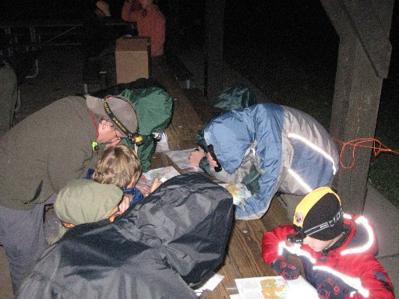
Preparation for the Night O

Night Meet Participants
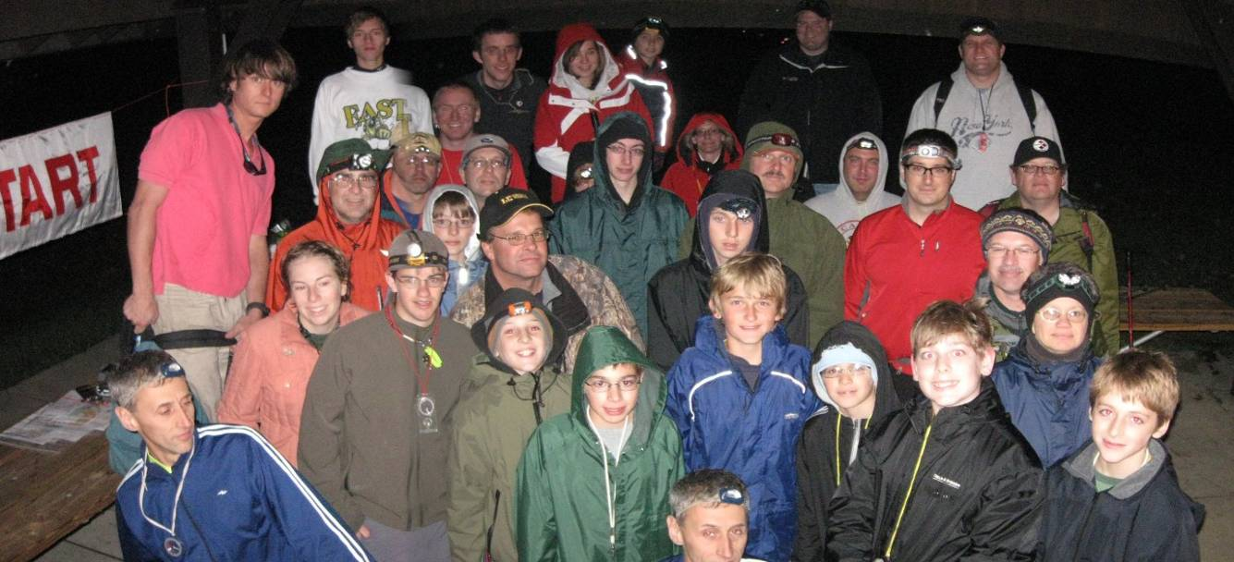

Pine Ridge Park, November 8, 2009
It was an exceptional day on which to end the 2009 orienteering season for WPOC. The temperature was in the mid-60's with hazy sunshine; it was an ideal day to do some orienteering. We had a good turnout with 37 starts, although a few people ran the white or yellow course strictly as a warm-up for the score course leading to some unexpectedly fast winning times.
The white and yellow courses were a bit long, due to the limited loops in the trail system at Pine Ridge. The white course had two streamered sections to help "create" a loop where there wasn't one. The yellow course went all the way over the mountain and back. The 90-minute score course had 21 controls scattered throughout the park with seven 10-point controls, seven 20-point controls, and seven 30-point controls. In the "Controls" section of the score course results, the three numbers represent how many 10-point, 20-point, and 30-point controls each person found. It was surprising that four people found all 21 controls, although two of them were very much beyond the 90-minute time limit. Alexis would probably have found all controls as well; but he didn't notice that he had missed two controls before he finished. Jim Wolfe was meet director.
We had a few newcomers, although only one group required instruction. The others relied on previous experience elsewhere to go out for the first time. Several members followed the suggestion to renew for 2010 at the meet and one person, Dave Langton, rejoined the club after an absence of one year.
Thanks to Barbara Johnstone, Mike & Zach Ward, Al Sheaffer, Bill Unger and Giuseppina Mecchia for running registration. Thanks to Joe Logan, Dave Torick, and Ray Wygonik for running start/finish. Thanks to Bryon Roland, Mary Roland, Mike Adametz and Alexis Rzewski for helping with control pick up. Also, thanks to Laurie Opila for managing the pot luck dinner.
The schedule for 2010 should be out in late January.
White Course 2.2 km 11 controls
Toby Angove |  | 15:00
Luca Rzewski | WPOC | 44:50
Dave & Samayeh | WPOC | 46:12
Anita Rzewski (3) | WPOC | 57:36
Livingston Family (5) | WPOC | 65:23
Mark & Peter Reith (4) |  | 67:05
Heather Young (4) |  | 71:25
Deb Skander, David & Brian Pickford |  | 89:00
Burdick (4) |  | 92:08
Yellow Course 3.65 km 10 controls
Brian Ottinger |  | 38:10
Alexis Rzewski | WPOC | 40:45
Dave & Mary | WPOC | 51:16
Sherry Shank | WPOC | 63:44
Bill Unger | WPOC | 70:45
Michael & Zach Ward | WPOC | 75:00
Joan Ferraro |  | 79:31
Barbara Johnstone | WPOC | 92:32
Sandy Augustine & Janice Shields | WPOC | 96:00
Brad Pinter (3) |  | 120:50
Ron Becker |  | 154:38
Al Sheaffer did not punch control #3 65:16 | WPOC | DSQ
Score Course 90 minutes 21 controls 10-30 points per control 15 point penalty per minute late
Name | Club | Controls | Time | Penalty | Score
Toby Angove |  | 7, 7, 7 | 67:00 | 0 | 420
Bryon Roland | WPOC | 7, 7, 7 | 79:12 | 0 | 420
Alexis Rzewski | WPOC | 5, 7, 7 | 69:29 | 0 | 400
Dave & Samayeh | WPOC | 5, 6, 7 | 89:32 | 0 | 380
Brian Ottinger |  | 5, 6, 5 | 83:53 | 0 | 320
Fedya Kleshchev | ORCA | 5, 6, 5 | 84:24 | 0 | 320
Danielle Pisarcik | WPOC | 5, 5, 4 | 89:40 | 0 | 270
Joe Logan | WPOC | 6, 4, 4 | 81:42 | 0 | 260
M.C. Tschantz | ECP | 5, 5, 3 | 84:26 | 0 | 240
D & M Lorenz | WPOC | 3, 4, 4 | 89:00 | 0 | 230
Jason Maruccio | WPOC | 5, 4, 3 | 84:48 | 0 | 220
Ray Wygonik | WPOC | 4, 4, 3 | 85:14 | 0 | 210
Loretta Opila | WPOC | 3, 2, 2 | 92:00 | -30 | 100
Frank Ferraro | WPOC | 7, 7, 7 | 131:45 | -615 | -195
Michael Adametz | WPOC | 7, 7, 7 | 156:34 | -990 | -570
Judith Scanlon & Jamie Billings | ECP | 2, 1, 2 | 172:00 | -1230 | -1130
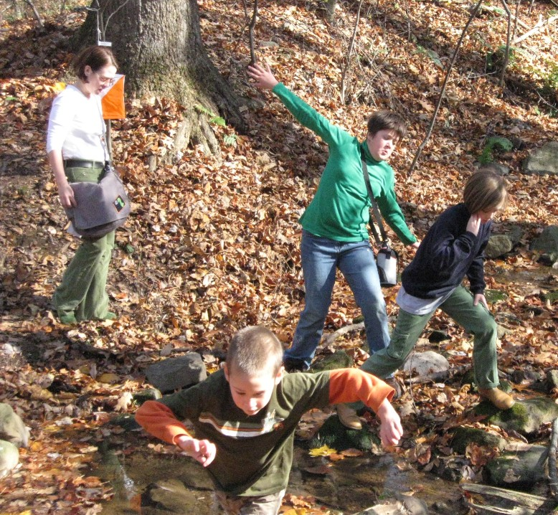
Pine Ridge White Course Fun!
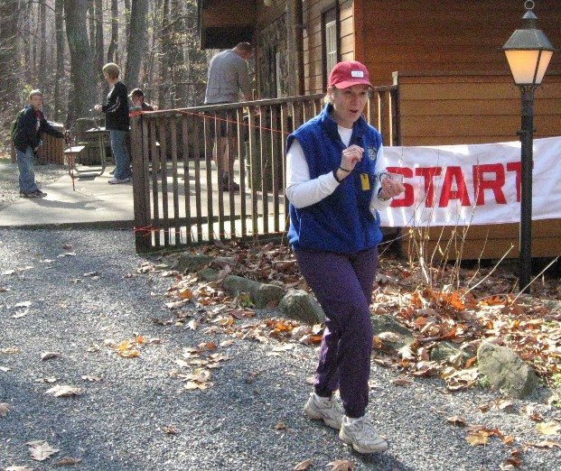
Joan Ferraro heads out at Pine Ridge!
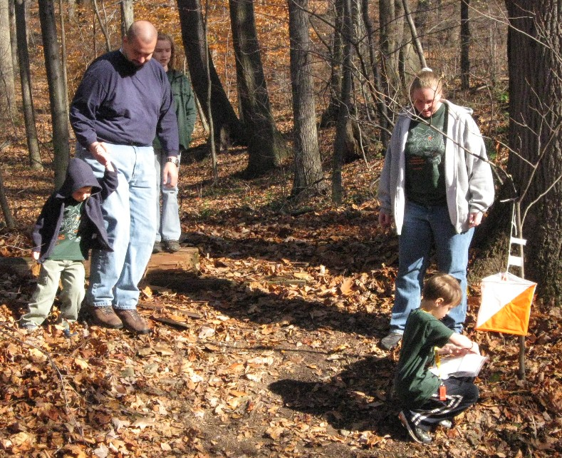
Family Fun at Pine Ridge!

