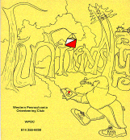
Jim Wolfe – President – (814) 255-6606
jlwolfe@atlanticbb.net
Bryon Roland – Vice-President – (724) 357-9328
bmann66@comcast.net
Jennifer Livingston – Secretary – (724) 770-1120
jen.livingston@pobox.com
Club website – www.wpoc.org

A-Meet: June 25 and 26th, 2011 – Keystone Capers
June 25 and June 26, 2011 WPOC is sponsoring an A-meet called the Keystone Capers it will be held at the Keystone State Park and the Deer Lakes Park. Since an A-meet will be held at those 2 parks in 2011, no events can be scheduled at these parks in 2010. At the Fall club meeting held on November 9, 2009 it was discussed how much work and coordination is needed to pull an A-meet together so when you can help Jim Wolfe out you need to contact him and let him know what you are willing and able to help with moving forward. I am sure there will be information to follow in the near future.

2009 Draft Minutes from the Annual Club Meeting – 11/8/2009
The meeting was held at the Pine Ridge Lodge after the last meet of the year and pot luck dinner.
Jim Wolfe called the meeting to order at 2:45pm.
- Minutes from 9 Nov. 2008 were approved as submitted.
- Election of Non-Officer Directors
The following were re-elected to two-year terms. Each was nominated and seconded and elected by acclamation, as there were no other nominations.
Non-Officer Directors: Barbara Johnstone and Alexis Rzewski
- Report on past year's achievements.
The club thanked Mary McElhinny for her service as volunteer coordinator. Dave Torick volunteered for the 2010 year.
A Promotion Coordinator was discussed. There were NO volunteers.
The 501c (3) status was explained.
- A financial report for 2009 through November 4 was provided. It showed the club to be financially stable. A tentative rough budget for 2010 was also provided for planning. The 2009 and 2010 budget are not attached here; the complete report will be sent to the membership in January after the fiscal year is over.
- Discussion of Goals for 2010.
Jim Wolfe discussed the revision of Keystone SP and Deer Lakes maps to meet the national standards. The membership also discussed the making of one new map. Most support was for Mingo Creek. Also, dates were suggested for the 2010 meet schedule. Meet Directors and Vetter’s are needed. The embargo for the A-meet in 2011 on Keystone SP and Deer Lakes was explained.
- Discussion of A-meet.
A list of A-meet related tasks was distributed to the membership and tasks were explained as needed. Visual aids of meet packets, t-shirts, and prizes were provided as well as explanations of how an A-meet works. The membership was asked to volunteer (by contacting Jim Wolfe) for many of the tasks that do not require advanced orienteering skills. It was suggested that the membership hold an extra meeting next late spring or early summer (perhaps at an orienteering meet) to discuss the A-meet in more detail.
- No other new business.
Meeting adjourned at 3:50pm.

2010 Schedule
The remaining WPOC club events are as follows:
- Coming Soon - Sunday, June 6, 2010 – IUP CO-OP Park (Farm side) – White, Yellow, Orange and Red Courses – Meet Director – Ray Wygonik
- Sunday, August 29, 2010 – Stackhouse Park – White, Yellow, Orange and Green Courses – Meet Director – Al Sheaffer
- Sunday, September 19, 2010 – Camp Twin Echo - National Orienteering Day Meet – White, Yellow and Brown Line Courses – Meet Director – Jim Wolfe
- Sunday, October 3, 2010 – Boyce Park – White, Yellow, Orange and Scramble Courses – Meet Director – Dave Battista
- Sunday, November 14, 2010 – Pine Ridge Park – White, Yellow and 90 minute Score – Meet Director – Bryon Roland

2010 Club Dues
If you haven’t already, now would be a great time to renew your club membership for 2010. Your club needs You! The membership application is available at www.wpoc.org

Event recaps:
Raccoon Creek State Park - Raccoongaine Results - March 21, 2010
It turned out to be a sunny, warm day with the temperature around 70. The good weather was probably the reason that so many people who were not pre-registered showed up. At least a dozen more than anticipated came to the event. As a consequence, at the end of registration there were not enough maps for each person to have one. Fortunately, there were enough so that each team received at least one. After that, everything went well - no one had any injuries beyond scratched up legs and general exhaustion; no one had to be searched for; and all the controls were where they were supposed to be.
A total of 111 people participated in this first Raccoongaine. They were about evenly split between the 3-hour (34 teams and individuals) and 6-hour events (27 teams and individuals). 50 controls were placed in the forest with values of 10, 20, 30, 40, or 50 points. Four controls (mystery controls) were not marked on the competition map; at four other controls (mother controls) that were marked, there were maps showing where one mystery control was. Competitors could choose to go to the mystery control or not; all mystery controls were 20-point controls. The total points possible were 1370, with point values mostly determined by distance from the start and difficult in getting to them; we did not expect anyone to reach that total. The overall winner for the 3-hour was Team Dole from Ohio with 320 points and the overall winner for the 6-hour was Harper Forbes from Ontario with 1150 points. A detailed analysis of the event and results can be found at www.wpoc.org.
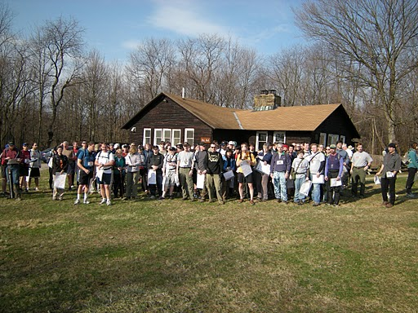
Start of Raccoongaine

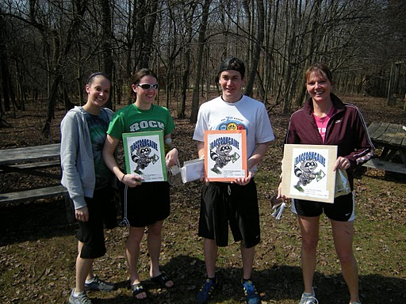
Happy 3-Hour Finishers!
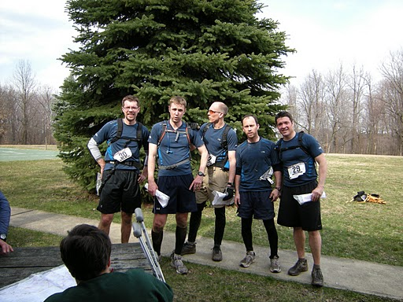
Satisfied - 6- Hours Finisher!
Hartwood Acres – April 18, 2010
It was a nasty looking day, overcast, temperatures in the upper 40's and low 50's with an occasional sprinkle of rain. Nevertheless, we had a pretty good turnout - 92 people with 43 starts. Jennifer Livingston was meet director and Dave Battista was vetter. Judging by the finishing times, the courses were fairly challenging. A number of competitors noted the up and down nature of the green course; but after all it was the expert level course. (“My favorite part was that this was the first meet since WPOC was formed at which I felt it was fair for me to compete on a course.” – Jim Wolfe)
Thanks to Alexis Rzewski, Loretta Opila, and Ray & Mindy Wygonik for handling registration. Thanks to Dave Battista for providing instruction. Thanks to Joe Logan and Dave Torick for handling start/finish. And thanks to Dave Torick, Joe Logan and Alexis Rzewski for helping to pick up the controls.
White Course 2.35 km 85 m climb 8 controls
Sandy Augustine & Janice Shields | WPOC | 55:05
Talbots (4) |  | 56:53
Kukieza Family (4) |  | 66:37
Emma Livingston (3) | WPOC | 83:34
Bobbi Battista (4) | WPOC | 83:45
Amanda & Liz |  | 85:55
Michael & Alex |  | 85:55
Alan, Jordy & Alex |  | 95:47
Loretta Opila | WPOC | 108:10
Mario Iasella (3) |  | 110:00
Yellow Course 3.75 km 115 m climb 9 controls
Nick McCullar & Otto |  | 40:27
Naomi Jarvis (2) |  | 58:34
Jeff Campbell (2) |  | 76:51
Christopher Corbran |  | 93:36
Troop 150 Patrol 2 (5) | BSA | 99:30
Troop 150 Bear Patrol (5) | BSA | 102:55
Phil Breidenbach (2) | ECP | 110:10
Mary Bates (2) |  | 117:02
Geoff Hogole (2) |  | 123:37
Rich Szwaczkowski (5) Troop 399 | WPOC | 152:35
Orange Course 4.4 km 175 m climb 10 controls
Jim Wolfe | WPOC | 50:13
Jonathan Edwards |  | 62:54
Jason Gray & Brad Thompson |  | 68:39
Donald Tedrow |  | 84:10
Martha Gray & Matt Janick |  | 107:10
Chesky (2) |  | 128:20
Barbara Johnstone | WPOC | 140:53
Team Janowitz |  | 184:42
Joan Ferraro - missed control #1 121:33 | WPOC | DSQ
Reihl - Schaaf (3) - missed control #8 140:49 |  | DSQ
Trekkin' Teachers (3) - completed course but did not get start time |  | DNS
Green Course 6.5 km 310 m climb 12 controls
Dave & Somayeh | WPOC | 81:17
Jim Trautmann | WPOC | 91:09
Jerry Agin | WPOC | 96:00
Eric Standish |  | 98:17
Frank Ferraro | WPOC | 99:01
Joe Logan | WPOC | 107:12
Jason Gray & Brad Thompson |  | 115:15
Hodos (4) |  | 127:45
Mark & Catherine |  | 158:59
Alexis Rzewski - mispunched control #11 54:37 | WPOC | DSQ
Anne, Allie, Meaghan & Gretchen - missed control #11 230:43 | WPOC | DSQ
Ray Wygonik - only went to 3 controls 56:37 | WPOC | DNF
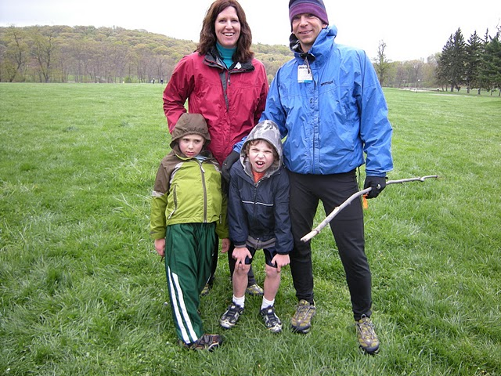
Dave's Family at Hartwood

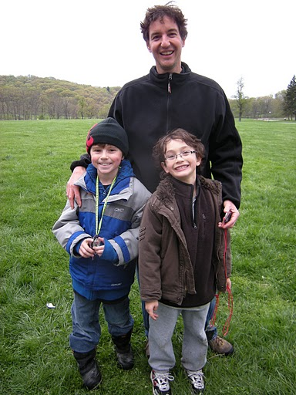
Orienteering makes you Smile ☺
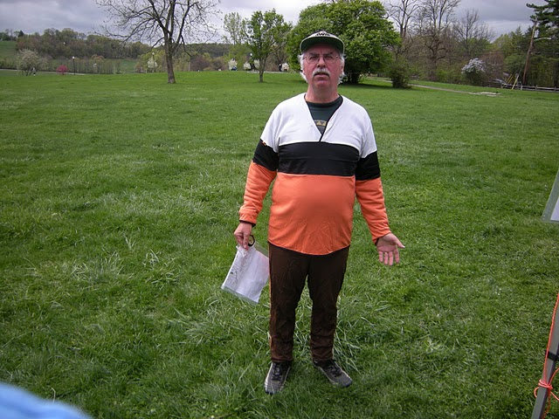
Love that shirt - Where can I get one?

Blue Spruce Park - May 15, 2010 – Night Meet
It was an almost ideal night for orienteering. A clear night with a temperature of about 60º at the start and about 50º at the end. There was no wind and no moon. Despite the good conditions, we had a light turnout with no-shows from several people who indicated they would be coming and almost no one coming who did not send prior notice.
There were 40 controls. Ten of them were worth 10 points each; ten were worth 20 points each; ten were worth 30 points each; and ten were worth 40 points each for a total of 1000 possible points. There was a 25 point per whole minute penalty for each minute late. Each punch card is listed separately in the standings below, even if some people went on the course in a group. The times and scores should make it clear who went together. Jim Wolfe, meet director, designed the course so that the high-point controls were scattered over the map. The idea was to allow everyone, including those with less experience, to reach at least one 40-point control. Some high-point controls were distance challenges (far away but on or near a linear feature); some required finding a good attack point; and some were route challenges.
An analysis of the punch cards shows that all but one person did visit at least one 40-point control. The least visited controls were in the extreme south (15, 24, 32 and to some extent 40). This was understandable because these were somewhat isolated and it was uphill all the way to them. All of the controls were visited by someone; but among the least visited was a surprising one, #17. It was near the main road with an easy attack point but only 3 people when there. And naturally, control #1 was visited by nearly everyone - it was very easy to get to. It was not expected that anyone would reach all of the controls in the time allowed - the expected high for controls was 32-35; so the course turned out to be a little harder than expected.
We had one person re-join the club. Tammy Cash, who had been a member a few years ago, joined again. Welcome back Tammy. Thanks to Laurie Opila for helping with registration. Also, thanks to Sherry Shank, Curt Mertz, Bryon Roland and Mary Roland for helping with control pick up.
Night-O Score Course 2 hours 40 controls Points as stated above
Name | Club | Controls | Time | Penalty | Score
Alexis Rzewski | WPOC | 29 | 2:01:17 | -25 | 695
Bryon Roland | WPOC | 26 | 1:56:11 |  | 680
Dave Torick & Somayeh Nassiri | WPOC | 21 | 1:58:19 |  | 550
Dave Battista | WPOC | 22 | 1:58:26 |  | 540
Mary Roland | WPOC | 20 | 1:51:14 |  | 410
Chris & Joel Scanga |  | 14 | 1:57:09 |  | 390
Joe Logan | WPOC | 18 | 1:47:30 |  | 380
Ethan Goldblum, Manej, Orkun & Ashik | CMU | 15 | 1:52:40 |  | 380
Sherry Shank | WPOC | 14 | 1:53:07 |  | 360
Curt Mertz | WPOC | 14 | 1:53:07 |  | 360
Peggy Mathieson |  | 13 | 1:54:11 |  | 310
Linda & Tom Gray |  | 13 | 1:54:11 |  | 310
Robert Buraczynski | CNYO | 14 | 1:43:27 |  | 290
Michael Cash, Emilea, Keara & Mea |  | 13 | 1:52:13 |  | 280
Tammy Cash, Meaghan, Megan & Tressa | WPOC | 13 | 1:52:13 |  | 280
Luca Rzewski | WPOC | 14 | 1:58:05 |  | 280
Al Sheaffer | WPOC | 11 | 1:25:43 |  | 190
The Martins |  | 8 | 1:47:58 |  | 160
Eric Steinbring | WPOC | 6 | 1:53:23 |  | 130
Josh Weltner | WPOC | 12 | 2:08:40 | -200 | 110
Angela Weltner | WPOC | 12 | 2:08:40 | -200 | 110
Joe Weltner | WPOC | 12 | 2:08:40 | -200 | 110
Tom Knapp | WPOC | 8 | 2:03:14 | -75 | 85
