
Jim Wolfe – President – (814) 255-6606
jlwolfe@atlanticbb.net
Bryon Roland – Vice-President – (724) 357-9328
bmann66@comcast.net
Jennifer Livingston – Secretary – (724) 770-1120
jen.livingston@pobox.com
Club website – www.wpoc.org

2009 Events:
We have 5 remaining meets scheduled for 2009. The events are as follows:
- Sunday, August 16, 2009 – Keystone State Park – New Map
- Sunday, September 20, 2009 – Blue Spruce Park – National Orienteering Day
- Sunday, October 4, 2009 – Deer Lakes Park - White, Yellow, Orange, Scramble
- Saturday, October 24, 2009 – Camp Seph Mack – Night Meet
- Sunday, November 8, 2009 – Pine Ridge Park – Pine Lodge Party
Please check the website for the specifics of each event and hope to see everyone at least 4 of the 5 meets!

WPOC Flyers for 2009 Meets
On the WPOC website (www.wpoc.org) under the Flyer bullet on the left of the website there are flyers for every WPOC event for 2009. The flyers contain information and directions for every meet and are they are great to print up and disperse at your local meeting places and to help promote the club. We are always looking for new club members and we want to do all we can to promote our sport and club. A happy and healthy club is a growing club.

Volunteering:
We will need every club member to volunteer for the remaining 5 meets in 2009 to comfortably staff the remaining schedule. Remember volunteering takes no special skills and only requires about 1.5 to 2 hours help on the day of the meet and you can still go out on the course. Every club member should make it their personal goal to volunteer for at least one meet this year.

Reports from the VO Festival – May 16, 2009
Based on the reports from the VO Festival, things well very well,
despite some rain. Following are the reports that Jim received.
From Dave Battista:
It was pretty busy from the get go - a lot of interest. Tom and I
finished at 1 pm and I am sure the rain came soon after. I don't think
Frank (from Grassroots) decided to do the checkpoint thing? He had a
ton of kids on his obstacle course.
From Stephanie Martineau:
It was pretty steady from the time I got there at 1. A squall came
through around 2:15? First it was windy. The folks from VO gave us a
warning, and we put away much of the stuff to keep it dry. The rain
wasn't too heavy but with no side walls, the tables got wet. More
worrisome was the thunder. The sun came out again, and we put things
back out after wiping off the table. (Maybe the boxes should have a
towel or paper towels for such emergencies.)
From Tom Knapp:
We were talking to people pretty constantly until the second band of
showers came through. The rain pretty much put a damper on the whole
festival. Attendees thinned out and dropped off when skies darkened. By
4:00 o'clock things thinned out and some of the groups began leaving.
The festival shut down at 5 instead of 6 - even VO shut down their
tents
On the bright side I thought we were pretty busy from when I got there a
(little after one) until a bit after the second set of showers after
3:15. I think over half of the folks took only the club pamphlet and
said they would get the schedule and other info from the website. We
really needed at least two people. Usually while in an explanation of
orienteering someone else gets attracted to the display or hearing the
explanation and stop. The second person engages them at the beginning.
The control and the pattern of the punch on the punch card drew smiles
and "Oh, that's neat." It's a good visual for folks that engages them.
I think we fit in the festival well. Some folks had orienteered before,
many were hikers or used maps, and some had scout or military experience
with maps and compasses. Our flexibility with fast/leisurely,
individual/social gives something to offer everybody who came through.
A good percentage of the people I spoke with were from Westmoreland
County or Monroeville and were close to at least one of the parks to
give it a try.
WPOC Face Book
Alexis Rzewski has created a Face Book page and if anyone wants to join the FB group, just look for the group under the title “Western Pennsylvania Orienteering Club”.
Alexis is also the responsible party that takes all the great photos at the meets.

Event recaps:
Camp Twin Echo, May 9. 2009
Although the weather alternated between threatening and sunny, there was no rain. The woods were very wet and muddy from the previous rains; but there were lots of wild flowers to see. Turnout was quite low. It is hard to identify the cause: weather? Remote location? Mother's Day weekend? However, those who did come had a good time. We tried two new courses at this event. We had a Brown course - the shortest version of a course that requires expert skills. It was only 3.6 km long but provided some interesting challenges. We also had a Line course - participants had to follow a 5.4 km twisting and turning line and find the controls that were on the line (they were not marked on the map). This proved to be a fairly difficult task. A time penalty system was used for controls that were missed on the course.
Jim Wolfe was meet director. Thanks to Joe Logan, Ray Wygonik, Bill Unger, Dave Battista, Mary McElhinny and Laurie Opila for running the Registration. Thanks to Al Sheaffer for covering Start/Finish. Thanks to Bryon Roland for helping with Instruction. And thanks to Dave Battista, Bill Unger, and Alexis and Luca Rzewski for helping with control pickup.
White Course 2.21 km 9 controls
Alex, Lucas, River & Kevin | Troop 78 | 46:02
Leaders (2) | Troop 78 | 50:22
Andy Miller | BSA | 50:43
Ryan Adams | BSA | 50:43
Jordan Brant | BSA | 50:43
Dan Formica | BSA | 52:46
Isaac Joseph (4) | BSA | 53:10
Ungers (4) | WPOC | 67:45
Sandy Augustine & Janice Shields | WPOC | 74:37
Yellow Course 3.20 km 10 controls
Mary McElhinny | WPOC | 47:33
Chris & Olivia Peters | WPOC | 54:00
Justin Cleavland & Skip Rooney |  | 59:04
Troop 78 (6) | BSA | 91:43
Luca Rzewski | WPOC | 123:35
Jan Reihl |  | 123:40
Barbara Hemstreet |  | 131:37
Brown Course 3.60 km 9 controls
Alexis Rzewski | WPOC | 41:39
Lorenz | WPOC | 51:47
Dave Torick & Jim Hokanson |  | 64:23
Joe Logan | WPOC | 77:30
Justin Cleavland & Skip Rooney |  | 87:19
Dave Battista | WPOC | 88:38
Al Sheaffer | WPOC | 97:28
Loretta Opila | WPOC | 138:25
Line Course 16 controls (about 5.4 km) 10 minute penalty for each missed control
Name | Club | Missed | Return | Penalty | Total Time
Alexis Rzewski | WPOC | 3 | 89:55 | 30:00 | 119:55
Dave Torick & Jim Hokanson |  | 1 | 115:44 | 10:00 | 125:44
Ray Wygonik | WPOC | 2 | 150:43 | 20:00 | 170:43
Jennifer Livingston | WPOC | 1 | 163:19 | 10:00 | 173:19
Stephanie Martineau | WPOC | 3 | 158:43 | 30:00 | 188:43
Bryon Roland found only 5 controls | WPOC | NA | 76:11 | 0 | DNF
Paul & Kate Sutcliffe found only 8 controls | WPOC | NA | 148:01 | 0 | DNF

Stackhouse Park, May 31, 2009
It was a somewhat overcast and humid day; but the temperatures were in the low to mid 60's. So, it was very reasonable orienteering weather. Unfortunately, that didn't seem to be enough to attract many people to the meet. We had an event with one of the lowest number of starts we have ever had. We did add two new members - welcome to Janice Shields and Linda Grant.
The times on the Yellow course were generally somewhat slow. A few participants on Yellow had trouble finding control # 8 because the trail junction they wanted to use as an attack point was not very distinct. Nevertheless, everyone seemed to enjoy the courses and the park. The Score course had two controls worth 5 points, eight controls worth 10 points, eight controls worth 15 points and two controls worth 20 points for a total of 250 points. It was thought that control #12 might get complained about because it was in a fairly thick area. But, it turned out that all participants on Score went to #12 and no one complained; one even thought it was a good control location.
Al Sheaffer was meet director; he designed some very good courses. Thanks to Barbara Johnstone, Laurie Opila, Mary McElhinny, Danielle Pisarcik, and Dave Torick for running registration. Thanks to Sherry Shank, Curt Mertz, Alexis Rzewski, and Dave Torick for helping with control pick up.
White Course 1.93 km 10 controls
McGrath & Murphy (4) | GSA | 52:52
Team #1 (Grace, Erin, Lizzie) (4) | GSA | 53:30
Twasome (6) | GSA | 56:33
Sandy Augustine & Janice Shields | WPOC | 62:00
Susan Lee |  | 146:50
Yellow Course 3.55 km 10 controls
Dave Torick | WPOC | 36:39
Alexis Rzewski | WPOC | 44:59
Curt & Sherry | WPOC | 55:44
The Peters family (4) | WPOC | 70:22
Tom & Linda Gray |  | 88:05
Michael & Carol Adametz | WPOC | 93:08
Loretta Opila | WPOC | 102:51
Barbara Johnstone | WPOC | 116:25
Tom Kaveney & Linda Grant missed last 3 controls 144:00 | WPOC | DNF
Score Course 90 minutes 20 controls 5-20 points per control 10 point penalty per minute late
Name | Club | Controls | Time | Penalty | Score
Alexis Rzewski | WPOC | 20 | 77:35 | 0 | 250
Dave Torick | WPOC | 18 | 86:23 | 0 | 235
Curt Mertz | WPOC | 12 | 88:37 | 0 | 155
Michael Adametz | WPOC | 14 | 94:26 | 40 | 135
Mary & Danielle | WPOC | 12 | 95:40 | 50 | 85
Sherry Shank | WPOC | 5 | 85:45 | 0 | 45
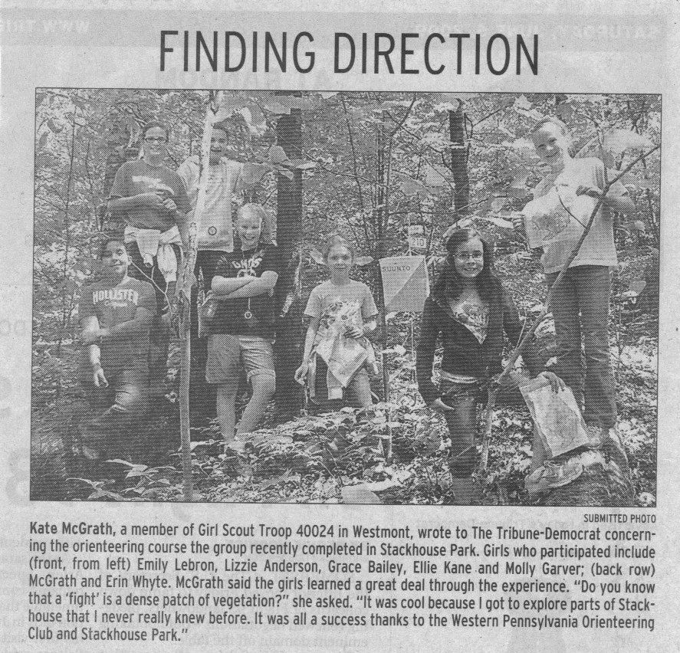

Boyce Park, June 14, 2009
It was a very pleasant day for June in Boyce Park. The turnout was ok but somewhat less than expected. We did get a couple of newbie’s from the VO Festival and the library postings; but we were hoping for a lot more. Phil Martineau, meet director, designed some challenging courses, especially the orange and red ones. The thick vegetation in Boyce Park, along with the many trails (some unmapped) make it difficult to design good advanced courses; but based on the times and the comments from the competitors, Phil did a good job. There was one moment when we thought there was a problem on the yellow course; as three people who finished at nearly the same time reported not finding one control. However, when we checked, the control was in the proper place and no one finishing later had any problem with the control.
Thanks to Jerry Agin, Barbara Johnstone, Al Sheaffer, Loretta Opila, and Bill Unger for handling registration. Thanks to Alexis Rzewski for providing instruction. Thanks to Stephanie Martineau for final vetting and handling start/finish. And thanks to Bill Unger, Alexis Rzewski and Al Sheaffer for helping to pick up the controls.
White Course 1.9 km 30 m climb 9 controls
Luca Rzewski | WPOC | 26:53
Deb Burgess |  | 28:52
Michael Betti (2) |  | 45:30
Beamer Family (4) |  | 53:19
Don Tedrow (4) |  | 73:05
Christian & Zachary Restifo completed course at 13:36:38 |  | DNS

Yellow Course 3.2 km 78 m climb 9 controls
Al Sheaffer | WPOC | 50:32
Matteo & Jerome Pesenti |  | 54:10
Jackson Bree (3) |  | 68:25
Loretta Opila | WPOC | 74:52
Sara Whitby |  | 79:45
Michael Betti (2) |  | 85:44
Casey Brienza (3) |  | 86:03
Jeff Arnold (5) |  | 94:40
Joan Ferraro |  | 181:43
Rob Graham did not find #6 87:50 |  | DSQ
Dan Stoffel (2) mispunched #6 107:44 |  | DSQ
Tom Kaveney & Linda Grant did not find #6 146:05 | WPOC | DSQ
Michael Ward did not reach last two controls 151:05 |  | DNF
Orange Course 4.9 km 96 m climb 10 controls
Joe Logan | WPOC | 69:06
Randy Fazenmyer |  | 83:30
Rob Graham |  | 87:34
Marvin Walters, Anne & Dave Koenig |  | 207:17
Vizino Family (4) did not reach last control 118:57 | WPOC | DNF
Smell the Roses (2) did not reach last control 173:30 | WPOC | DNF
Bill Unger found only first four controls 91:05 | WPOC | DNF
Red Course 6.9 km 186 m climb 13 controls
Alexis Rzewski | WPOC | 70:40
Hannah Burgess | USMAOC | 92:44
Willy Nilly (3) | WPOC | 130:12
Frank Ferraro | WPOC | 143:40
Ray Povirk |  | 147:32
Andrew Shissler |  | 156:25
John Hinderliter mispunched control #10 121:48 | WPOC | DSQ
Jerry Agin found only first seven controls 105:30 | WPOC | DNF
Mary Bates (2) found only control #1 82:07 |  | DNF
Mike & Diane Lorenz lost punch card after #8 ~171:00 | WPOC | DNF

3nd Annual Beaver Street O-Meet, June 20, 2009
The event went very well. We had about 55 people attend. Some who registered didn't show up and others who never registered did. The bit of rain in the morning did scare off a few people who were bringing bikes and others switched to running. Before the event, we showed part of a new orienteering DVD now available for check-out from the Beaver Area Memorial Library. It's called "Orienteering: Getting Started- First Steps and Going for It" and was purchased with the money collected from last year's event. From this year's event fees we are ordering the book "There's a Map on My Lap" by Tish Rabe which is from the Cat in the Hat's Learning Library.
The new orienteering map provided quite a challenge to everyone; the previous map showed street names. There were no complaints except that we probably should have mapped a little better near #25 because it was unclear how to get to the corner of the building if you weren't already familiar with the area. One dad didn't understand he had to return in 60 minutes.
Following the event, the Beaver Area Memorial Library provided refreshments for the participants and then we awarded the top finishers in both categories...a backpack for biking and a fanny pack/water bottle holder for running. A kid’s course was also set up in the library and will be available to try for a couple of weeks.
Thanks to all the families and businesses that agreed to let us hang a control flag on their property. And thanks to the Beaver Area Memorial Library and staff for all their help in planning this event. Thanks to Scott, Jan, Jodi, and Jessica Zang and Tom Knapp (from WPOC) for helping with registration, finish, and control pick-up! Their help makes this so much more enjoyable. And thanks to Mrs. Kelly for allowing my daughter to participate with her family since I was required to stay at the start.
Jennifer Livingston, meet director
60 minutes; 30 controls; 5 points per control; -5 point penalty per full minute late
Name | Club | Controls | Time | Penalty | Score
Peggy & Tony |  | 20 | 57:58 | 0 | 100
Frank & Joan Ferraro | WPOC | 19 | 57:23 | 0 | 95
Scott & Jodi Zang |  | 18 | 58:35 | 0 | 90
Team Larson |  | 17 | 59:32 | 0 | 85
Team Ruppen |  | 16 | 54:11 | 0 | 80
Covatto Family (started 7 minutes late) |  | 16 | 58:12 | 0 | 80
Baker Family |  | 15 | 52:16 | 0 | 75
Kaden Ingros |  | 15 | 58:16 | 0 | 75
Team Kelly (and Emma) |  | 15 | 58:17 | 0 | 75
Diane & Elyse Morgan |  | 15 | 60:52 | 0 | 75
Roger Stoffram |  | 17 | 62:40 | -10 | 75
Jessica & Jan Zang |  | 13 | 55:34 | 0 | 65
The Undoubtfuls |  | 13 | 58:36 | 0 | 65
The Dolphins |  | 11 | 57:44 | 0 | 55
Atkins Family |  | 9 | 49:10 | 0 | 45
Teagle & Tanner |  | 15 | 70:44 | -50 | 25
Laracuentes Family |  | 24 | 94:00 | -170 | -50

Beaver Street O (Score Course, On Bike)
60 minutes; 30 controls; 5 points per control; -5 point penalty per full minute late
Name | Club | Controls | Time | Penalty | Score
Michael Crnjarich |  | 21 | 56:47 | 0 | 105

Feedback on the newsletter should be directed to Mary at runoutside99@comcast.net

