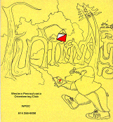
Jim Wolfe – President – (814) 255-6606 (nights)
(724) 357-6104 (days)
jlwolfe@atlanticbb.net
Bryon Roland – Vice-President – (724) 357-9328
bmann66@comcast.net
Jennifer Livingston – Secretary – (724) 770-1120
jenlivi@pobox.com
Club website – www.wpoc.org

Fall 2008 Events:
- Sunday - September 14, 2008 – Deer Lakes Park – National Orienteering Day Meet New Map – 11:00 am to 2:00 pm; New Map
- Sunday - October 19, 2008 – College Lodge – White, Yellow and Score – 11:00 am to 2:00 pm
- Sunday - November 9, 2008 – Pine Ridge Park – White, Yellow, 60-90 minute Score – 10:00 am to 1:00 pm – Early start time to allow for the social get-together that follows the meet.

Thanks to the Volunteers:
We have gladly welcomed a few new volunteers to the summer events in 2008 and the club greatly appreciates the help. With a very full fall schedule planned it is even more critical that we encourage WPOC members to volunteer for the meets. It takes NO special skills to help with a meet and we have flexibility on which shift works best. If you volunteer for the meet you get to do a course for free. An explanation of the jobs on the day of meet can be found on the club website, www.WPOC.org Only, WPOC club members can work as volunteers so I encourage everyone to join

Travels of Alexis Rzewski to a DVOA “A” Meet in Bethlehem, PA
Once a year, there are several "A" orienteering meets, sanctioned and supervised by USOF. This past Memorial Day weekend, there was one in the area of Bethlehem, PA, organized by the DVOA club. This meet attracted about 300 participants, and it spanned three days, and at the end of which, 10 athletes and four alternates are chosen to be in the team to represent the US at the world championships. The Rzewski family took the opportunity, and made it into an "orienteering vacation", combined with camping at a state park, and also to see some friends from the East Coast that they haven't seen in a while. Leaving Pittsburgh on Saturday morning and driving almost five hours, they reached the Lehigh University campus, and while Alexis picked up his packet, bib number, and other relevant information for the races that he pre-registered for, Giuseppina and kids registered as a "recreational" participant (as compared to "competitive" participant), and registered for a for White course. All courses used e-punching instead of hole punching, so participants that didn't own a SportIDENT device, had to rent one for $2/day. The Saturday course was a Sprint. All courses were on the Lehigh University campus, and all runners wore regular running shoes. Metal spiked orienteering running shoes were not allowed on this day. The courses were very fast; terrain was full of pedestrian concrete walk ways and alleys between buildings, and steps between upper terraces and lower streets. The Sunday course was a Middle distance, and it was to take place in the Hickory Run state park. After seeing the famous Boulder Field, a national natural landmark, and playing at the beach, we got to the event staging area, and while Alexis got ready for his pre-registered course, with a defined start time, Giuseppina and kids registered for a White course. The terrain was very woodsy, a bit flat in places, with controls not very visible from far distances due to the undergrowth, and not big terrain features. In this terrain, the experienced orienteer was at an advantage. At the end of the event, there was an ice cream social in one of the shelters, and there was also a huge birthday cake to a DVOA member, "Happy 90th Birthday Kent". The rest of the day was spent at the beach in the state park, and another visit to the amazing Boulder Field. Monday we woke up early, dismantled the tent, packed and cleaned everything, and got ready for our last day. After having a hearty and socially warm breakfast with our friends from Philly that joined us on our vacation, we then drove to the last orienteering event of the weekend, back to the Lehigh University, South Mountain Campus. On the way, we stopped by Jim Thorpe to see the Lehigh River Gorge, and the town has rafting and cycling trip concessionaries, a tourist train ride, and several restaurants. The place feels "Ohiopylish". Too bad we didn't have time to stop for long. At the South Mountain Campus, the meet was to offer the Long distance event. After Alexis started his run, nine-year old Luca signed up to do the White course by himself, and then Giuseppina and six-year old Anita signed up to do the same course, but to be done separately. At the end of the event, a sixty year old Peter Gagarin and former US champion announced the formation of the US team. Everyone clapped as the names were being announced. We then slowly made our way back to the parking lot; already half empty, and slowly made our way back to Pittsburgh. While driving back, we noted how remarkable it was that after 10 days of consecutive rain, we ended up with a perfect three-day trip. As we crossed the Laurel Highlands and our radio finally caught the local Pittsburgh FM radio stations, they were forecasting rain that evening. Great timing.

?? What does the acronym ARDF mean to the sport of orienteering?

Event recaps:
Stackhouse Park, Night Meet – May 17, 2008
WPOC's third night orienteering meet ran into a few problems with the weather. It was threatening rain most of the day and from about two hours before registration through the first hour of the event it rained. I thought very few participants would show up; but 20 intrepid orienteers did show up. Thanks to Laurie Opila and Mary McElhinny for running registration.
The scoring system for the night course was different from our typical score courses. There were 35 controls. Those numbered 1-9 were worth 5 points each; 10-19 were worth 10 points; 20-29 were worth 20 points and 30-35 were worth 30 points each. So, there were 525 possible points. There was a 20 point per whole minute penalty. Each punch card is listed separately in the standings below, even if some people went on the course in a group. The times and scores should make it clear who went together.
Because there is only one set of results, let me add some commentary/analysis. I planned the course expecting no one to getting all of the controls in the two hours allowed. I created a course that I thought I might be able to complete in three hours in daylight. I was figuring that the dark would slow even the best orienteers down a bit. The rain also slowed them down even more. The route I would have recommended for anyone trying to get all of them would have been to attack the controls in this order: 20, 8, 12, 35 (attack from the trail junction to the sw), 17, 3 then do a little backtracking to 22 (attack from the stream crossing to the south) and 13 and forward again to 18, 15, 32 (attack from the end of the bridge), 7, 5, 6, 27, 28, 30, 11 (a good attack point for 26), 26, 25 and 31 (25 provides a good attack point for 31 but not vice versa); then on to 29, 14, 23 (attack from the top of Caddy Trail), 33 (tough climb to the cliff), then down to 4, and up to 24 and a terrible climb to the Crystal Trail to reach 34; then 10, 2, 16, 21, 19, 9 and finally 1. At the meet, I estimated to Dave Torick that the optimum route might be 10-12 km. Actually, this route is only a little over 8 km. I was happy to see that every control, except #7, was visited by at least one person, although Alexis is the only person to visit #5 and #25. The most frequently visited controls were #16 and #19 with 15 orienteers reaching them; these were two of the easiest controls. Naturally, the controls on the northwest portion of the map were visited least often. #18 also had only a few visitors; I guess many didn't think it was worth the climb.

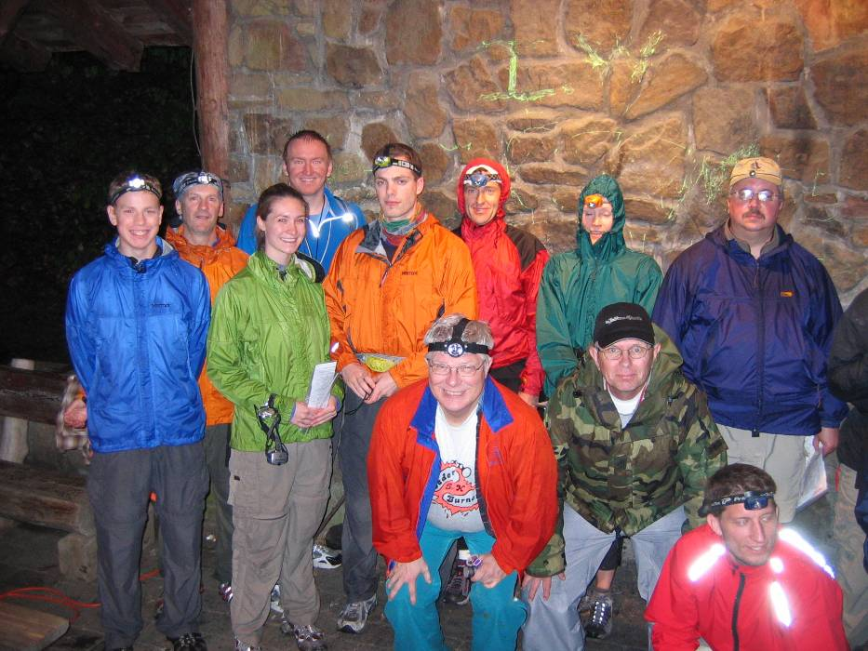
Night Orienteers at Stackhouse Park - We all look so excited and relatively dry!
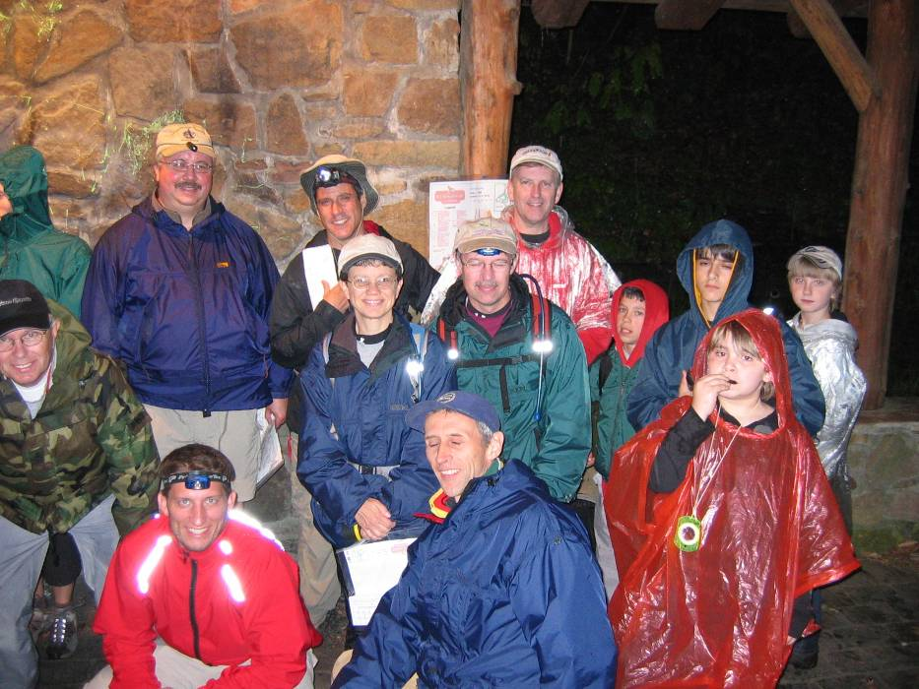

Night-O Score Course 2 hours 35 controls Points as stated above
Name | Club | Controls | Time | Penalty | Score
Alexis Rzewski | WPOC | 24 | 2:01:14 | -20 | 370
Dave Torick | WPOC | 20 | 2:01:26 | -20 | 310
Jim Hokanson | WPOC | 20 | 2:01:26 | -20 | 310
Mary McElhinny | WPOC | 16 | 1:57:07 |  | 240
Bryon Roland | WPOC | 16 | 1:57:07 |  | 240
Mike Lorenz | WPOC | 13 | 1:51:28 |  | 205
Will Lorenz | WPOC | 13 | 1:51:28 |  | 205
Jason Lorenz (Willy) | WPOC | 12 | 1:55:27 |  | 180
Jamie (Nilly) |  | 12 | 1:55:27 |  | 180
Dan Beggs |  | 11 | 2:03:59 | -60 | 115
Jack Molchany |  | 8 | 1:57:51 |  | 100
Vince Lovendoski |  | 8 | 1:57:51 |  | 100
Tom Gray |  | 8 | 1:46:02 |  | 95
Linda Gray |  | 8 | 1:46:02 |  | 95
Tim Bauer |  | 8 | 2:04:59 | -80 | 95
Tom Knapp | WPOC | 7 | 1:59:49 |  | 90
Steve Yewcik |  | 7 | 1:59:49 |  | 90
Andy Miller |  | 8 | 1:55:20 |  | 75
Ben Mical |  | 8 | 1:55:20 |  | 75
Ben Lovendoski |  | 8 | 1:55:20 |  | 75

Blue Spruce Park, June 21 2008
It was a warm, sunny day; but very few participants came to the meet. It was not at all clear why. Perhaps the choice of a Saturday event conflicted with too many other plans. Perhaps the price of gasoline is taking a bite out of recreational travel. Everyone who came seemed to have a good time, the few of them that were there.
Meet director, Bryon Roland, set courses that turned out to be more difficult than expected (judging by the times). Thanks to Bill Unger, Barbara Johnstone, Anne Hoover, Stephanie Martineau, and Mary McElhinny for running registration. Thanks to Al Sheaffer for handling start/finish. And thanks to Dave Torick, Alexis Rzewski and Mary McElhinny for helping with control pick.
White Course 2.2 km 9 controls
Alison, Jackson, Perry | WPOC | 57:50
Shaylin, Dylan, & Danna Marinelli |  | 67:30
Susan & Jacob Leri |  | 67:30
Tom Kaveney | WPOC | 72:30
Becky Carpenter & Jay Keenan |  | 92:40
Yellow Course 3.5 km 10 controls
Anne Sorrentino & Jody Lewandowski | WPOC | 85:30
Chris Peters |  | 97:22
Barbara Johnstone | WPOC | 105:40
Joe, Angela & Joshua Weltner | WPOC | 118:08
Pink Course 4.9 km 15 controls
Jim Wolfe (previously vetted course) | WPOC | 57:00
Dave, Lauren, Alison & Jackson | WPOC | 91:46
Bill Unger | WPOC | 108:10
Stephanie Martineau | WPOC | 117:10
Score Course 90 minutes 17 controls 10 points per control, -5 points per minute late
Name | Club | Controls | Time | Penalty | Score
Alexis Rzewski | WPOC | 17 | 87:46 | 0 | 170
Mary McElhinny | WPOC | 11 | 86:40 | 0 | 110
Joe Logan | WPOC | 8 | 89:41 | 0 | 80

Boyce Park, July 19, 2008
It was a very hot, humid day in Boyce Park. Nevertheless, we had a good turnout, including a couple of DVOA members and several NEOOC members. Because it was expected to be hot and because Boyce Park has so much green, the courses were designed to be a bit on the easy side. Everyone had a good time and seemed to appreciate the cold water and watermelon at the end of their courses. We had several people join the club and we gave away some Frisbees and whistles, courtesy of Mark Frank and DVOA. Thanks to Joe Logan, Wayne Richter, Loretta Opila, Mary McElhinny and Dave Langton for their smooth handling of registration. Thanks to Dave Torick, Bryon Roland and Alexis Rzewski for keeping track of start and finish. And thanks to Alexis and Luca Rzewski and Dave Torick for helping to collect the controls.
The next meet will not be until September 14, National Orienteering Day, on a new map at Deer Lakes Park.
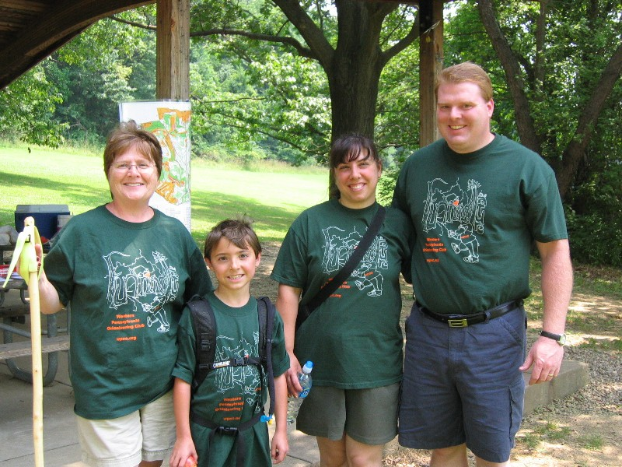
Weltner Family at Boyce Park - Love the WPOC shirts – way to support the club!
Course Results
White Course 1.85 km 45 m climb 8 controls
Luca Rzewski | WPOC | 22:19
Martin Erson | WPOC | 34:55
Tom Dean |  | 35:54
Margy Kearney |  | 40:28
Johnstone & Neuwirth | WPOC | 45:00
Josh Phillips |  | 46:33
Dusty Peters |  | 59:27
R. Laufer (Troop 111) |  | 77:45
D. Michaels (Troop 111) |  | 77:45

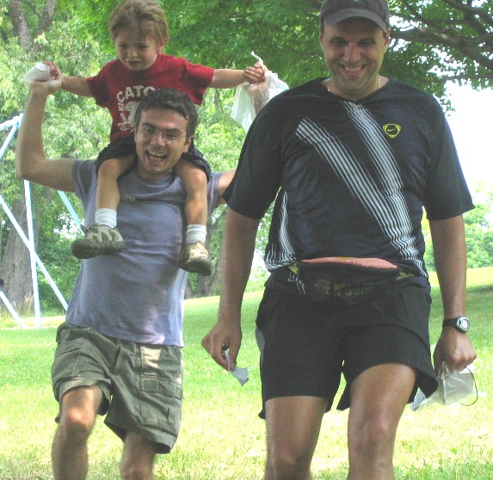
Everyone having fun on a sunny Saturday at Boyce Park
Yellow Course 3.25 km 105 m climb 9 controls
Pesenti Family |  | 57:40
Howard McIlvried |  | 65:48
Wayne Richter | WPOC | 67:06
Giuseppina Rzewski | WPOC | 73:51
Tim & Martin Erson | WPOC | 76:36
Johnstone & Neuwirth | WPOC | 77:55
Weltners (Joe, Angela, Josh & Rita) | WPOC | 78:43
Schultz & Gottschalk |  | 89:00
Andy Michaels |  | 100:34
R. Laufer (Troop 111) |  | 111:34
Max Erb |  | 127:14
Joe Monteleone | WPOC | 143:58
Samir & Nicholas Saba did not punch last control 59:02 |  | DSQ
Vizino Family finished 7 controls in about 120 minutes |  | OVT
Orange Course 4.41 km 110 m climb 11 controls
Alexis Rzewski | WPOC | 37:23
Dave Torick | WPOC | 44:16
Joe Logan | WPOC | 69:26
Steve & Nicole Schlotterbeck | WPOC | 104:15
Paul & Kathy Sutcliffe |  | 114:10
Koenig & Walters |  | 164:32
Mary & Dave missed 2 controls 89:20 | WPOC | DSQ
Tim & Martin Erson found only one control 25:41 | WPOC | DSQ
Jason Maruccio no card | WPOC | DNF
Green Course 5.51 km 115 m climb 12 controls
Alexis Rzewski | WPOC | 43:10
Petr Hartman | DVOA | 55:26
Dave Torick | WPOC | 62:21
Mark Frank | DVOA | 70:24
Nathan & Matt Hartmann | NEOOC | 98:27
Randy Fasemyer |  | 104:44
Alex & Lauren Flurie |  | 143:05
Bonnie & Ben Hartmann missed 5 controls 125:14 | NEOOC | DSQ
Bryon Roland no card | WPOC | DNF
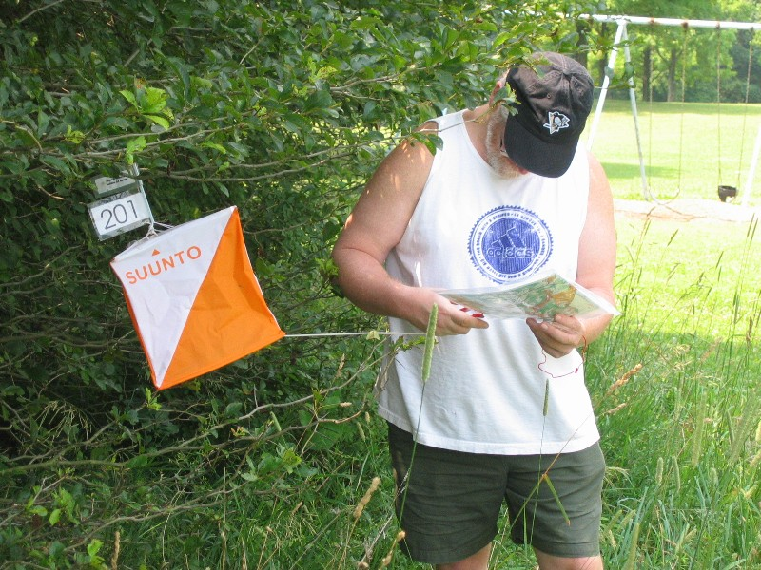
Having fun at Boyce Park!
Answer: Amateur Radio Direction Finding (ARDF) is an amateur map and compass sport that combines the skills of orienteering and radio directing finding. It is a timed race in which individual competitors use a topographic map, a magnetic compass and radio directing finding apparatus to navigate through diverse wooded terrain which searching for radio transmitters. The rules of the sport and international competitions are organized by the International Amateur Radio Union. Worldwide, the sport is most often referred to by its English-language acronym, ARDF, but is also referred to as radio orienteering or radiosport.

Feedback on the newsletter should be directed to Mary at runoutside99@comcast.net

