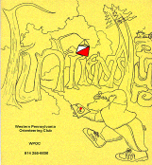
Jim Wolfe – President – (814) 255-6606
jlwolfe@atlanticbb.net
Dave Battista– Vice-President –
batty4@consolidated.net
Jennifer Livingston – Secretary – (724) 770-1120
jen.livingston@pobox.com
Club website – www.wpoc.org

A-Meet: June 25 and 26th, 2011 – Keystone Capers
June 25 and June 26, 2011 WPOC sponsored its first A-meet called the Keystone Capers it was held at the Keystone State Park and the Deer Lakes Park. This was the first A-meet held in western Pennsylvania in over 30 years. The club received a tremendous amount of support from DVOA. The full details about the A-meet with results and photos can be found at the www.wpoc.org website under the Keystone Capers bullet.

Remaining 2011 Schedule:
- Saturday, August 27, 2011 – IUP Co-op – College Lodge Side – 11:00 am to 2:00 pm – White, Yellow, Orange and Red Courses.
- Sunday, September 18, 2011 – Boyce Park – National Orienteering Day – 11:00 am to 2:00 pm – White (2), Yellow, Orange and Red Courses.
- Sunday, October 2, 2011 – Mingo Creek Park – shelter #4 – 11:00 am to 2:00 pm – White, Yellow, Orange and Scramble Courses.
- Saturday, October 22, 2011 – Camp Seph Mack – Night meet with mass start at 7;30 pm.
- Sunday, November 13, 2011 – Pine Ridge Park – Pine Lodge – earlier start, 10:00 am to 1:00 pm – White, Yellow and 90 minute Score course.
Orienteering Workshops:

Jim Wolfe will be conducting several orienteering workshops this summer that are open to the public. All of them are free; but you must preregister for some of them. You can see the complete list of workshops at www.wpoc.org/workshops.htm
Here is a brief list of ones you may be interested in that are open to the public. All are introductory workshops, except the last. Get driving directions at www.wpoc.org
- July 17, 2pm, Stackhouse Park, Johnstown (Shelter #1):
no preregistration, just show up
- July 23, 1pm, Keystone State Park, New Alexandria (beach house):
preregister by calling 724 668-2939
- Aug 6, 10am, Yellow Creek State Park, Penn Run (North Shore Pavilion):
preregister by calling 724 357-7913
Aug 20, 1pm, Keystone State Park, New Alexandria (Kell Visitor Center):
preregister by calling 724 668-2939
(This is not a repeat of July 23; it is for intermediate-level orienteering skills)

Event recaps:
Raccoon Creek State Park, March 27, 2011
It was a sunny, cold day with temperatures in the high 30's and low 40's, slightly cool but good running weather. A total of 140 people participated in Raccoongaine 2011. About two thirds were there for the 3-hour course (42 teams and individuals), with the rest (25 teams and individuals) participating in the 6-hour course. 50 controls were placed in the forest with values of 10, 20, 30, 40, or 50 points (10 controls for each value, a total of 1500 points). Point values were mostly determined by distance from the start and difficulty in getting to them; we did not expect anyone to reach them all. Four controls (mystery controls) were not marked on the competition map; at four other controls (mother controls) that were marked, there were maps showing where one mystery control was. Competitors could choose to go to the mystery control or not; all mystery controls were 20-point controls. The overall winner for the 3-hour was Allegheny Cyclery from with 460 points. The overall winner for the 6-hour was Randy Mitchell with 1000 points. Please visit the WPOC website under the Raccoongain bullet for photos, many more details and the results of this exciting event.
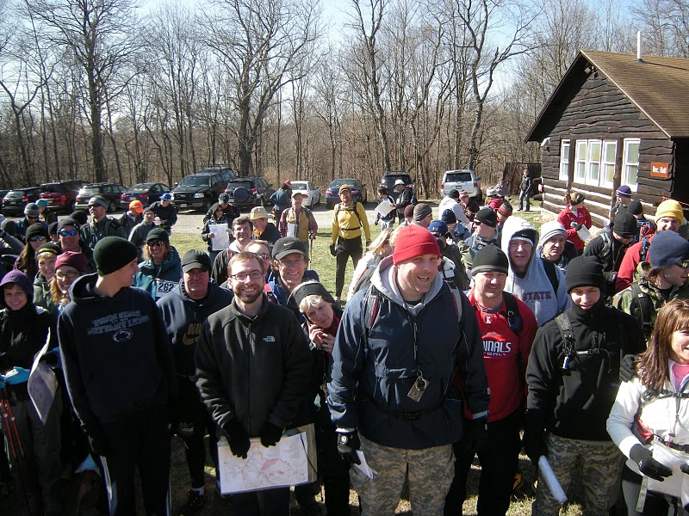

Happy Orienteers at the Start of the 2011 Raccoongaine !
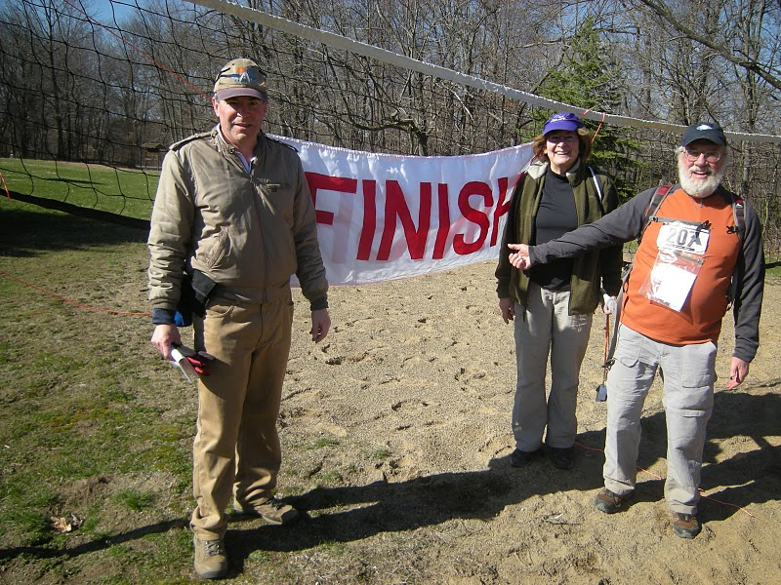
Fun time at the Finish of the 2011 Raccoongaine!

Hartwood Acres – April 10, 2011
It was a very warm, sunny day. We had a very good turn out (61 starts, about 111 people). There were many first-timers and quite a few who did two courses (white and yellow).
Jim Trautmann directed his first event. From the comments I heard, nearly everyone thought the courses were well designed. And there was a lot of thanks being given out by the participants as they left. I thought everything went very well. We had one new member join at the event. Welcome to David Ross & family. We also had a couple of previous members rejoin the ranks. Welcome back to the Joe Weltner family and the Frances Irvin family.
Thanks to Sherry Shank, Eric Filo and Loretta Opila for handling registration. Thanks to Joe Logan and Jerry Agin for handling start/finish. Thanks to Dave Battista for vetting the courses and mentoring Jim Trautmann in the course setting; also thanks to Dave for conducting instruction. And thanks to Dan Marincel, Alexis Rzewski, and Dave Battista for helping to pick up the controls.
White Course 2.2 km 45 m climb 9 controls
Nathaniel Olbrich & Andy Marsh |  | 26:04
Pizza Pyramid (3) |  | 46:57
Troop 399 Group 1 (4) | BSA | 51:16
Stacy Allison (2) |  | 52:51
Team Sniper (3) |  | 54:04
Jared Bosiljevac (2) |  | 54:40
Anita Rzewski (2) | WPOC | 54:48
Team Chenot (4) |  | 58:42
Waters Family (3) | WPOC | 59:53
Elsie Wilson (4) |  | 63:53
McKern (3) |  | 64:34
Musser (4) |  | 65:13
Bonnie Marsh & Theresa Rudolph |  | 69:18
Katie Kukieza (3) |  | 69:54
Team Dharwadker (3) |  | 73:55
Combest Family (3) |  | 75:33
Troop 399 Group 2 (4) | BSA | 77:58
Troop 399 Group 3 (4) | BSA | 94:09
Chad & Janelle |  | 95:00
AJ, Calvin & Geoff, Troop 139 | BSA | 102:21
Oscar's Honey (3) Found all controls; no official start |  | DNS

Yellow Course 3.9 km 80 m climb 10 controls
Kari Fladmark & Marion Hughes | FANA | 46:06
Corbran & Rodriguez |  | 65:40
Sandy & Pam Augustine | WPOC | 66:06
Luca Rzewski | WPOC | 69:05
Bobbi Battista | WPOC | 71:29
Loretta Opila | WPOC | 71:51
Ed Kauffman |  | 78:53
Troop 399 Group 2 (5) | BSA | 80:54
Lauren & Jesse |  | 82:38
Brian & Beth |  | 84:26
Robert Shields |  | 84:52
Troop 399 DJN & DC (2) | BSA | 94:35
Waters Family (3) | WPOC | 120:01
Jared Bosiljevac (2) |  | 120:22
Troop 399 Group 3 (3) Missed 2 controls; 84:21 | BSA | DSQ
Ron & Alex Mispunched one control; 86:51 |  | DSQ
Musser (4) Found only 6 controls; 103:14 |  | DNF
Troop 399 DM & BC (2) Found only 2 controls; 83:03 | BSA | DNF
Orange Course 4.5 km 175 m climb 11 controls
Nick McCullar |  | 86:16
Keith Irvin & Zack Finder (3) | WPOC | 122:02
Don Tedrow |  | 123:45
Sherry Shank | WPOC | 125:09
Team Chesky (4) |  | 130:54
David Ross | WPOC | 146:20
Janowitz |  | 148:13
Zachary Ross | WPOC | 160:20
Brady Ross Missed 3 controls; 172:43 | WPOC | DSQ
Green Course 6.6 km 210 m climb 11 controls
Andy Strat | QOC | 58:11
Alexis Rzewski | WPOC | 61:08
Tim Bauer |  | 70:46
Jerome Pesenti |  | 76:28
Jerry Agin | WPOC | 88:36
Dan Marincel | WPOC | 89:15
Hodos (3) |  | 111:12
Rats in the Night (2) |  | 114:31
Rhumb Runners (2) | WPOC | 114:55
Joe Logan | WPOC | 117:02
Dan Beggs |  | 153:07
Brian & Kevin Manley Found only 6 controls; 163:18 |  | DNF
Eric Filo No control card; 106:30 | WPOC | DSQ
Blue Spruce Park – May 15, 2011
It was a very wet day, having rained a couple of inches the day before and rained during the morning before the start window opened. Some paths were covered with water; streams that are usually only a few inches deep were at 2 feet or more. Everywhere it was muddy and slippery. Nevertheless, we did have a few intrepid participants, including several boy scouts working on their first class rating. Ray Wygonik designed some interesting and challenging courses and all the controls were where they were supposed to be. We tried to attract a few geocachers to the event by offering one course using GPS coordinates. But the only ones who showed up were the Grays who are club members. There were a lot of very positive comments about the courses. Everyone had a good. albeit wet, time. We had two families join the club. Welcome to the Nick McCullar and Barbara Jones families. Thanks to Loretta Opila and Alexis Rzewski for handling registration. Thanks to Joe Logan for helping with start/finish. Thanks to Bryon Roland, Dave Battista, the Weltner family and Rich for helping with control pickup. And thanks to Ray Wygonik, who helped with registration and start/finish and control pickup because we were short of volunteers.
White Course 1.9 km 60 m climb 8 controls
Andria Jones (3) | WPOC | 53:15
Drew & Landon | BSA | 59:45
Anita Rzewski (2) | WPOC | 60:15
Alan Caldwell (3) |  | 63:15
Michael Glasser (2) | BSA | 66:28
Yellow Course 2.4 km 115 m climb 8 controls
Luca Rzewski | WPOC | 44:50
David Ross | WPOC | 57:05
Brady Ross | WPOC | 65:22
Michael Glasser | BSA | 65:22
Caldwell |  | 69:45
Loretta Opila | WPOC | 82:44
Landon & Drew | BSA | 87:05
Jones (3) | WPOC | 93:50
Weltner Family (3) | WPOC | 96:02
Orange Course 4.3 km 170 m climb 11 controls
Chris Corbran & Tanya Rodriguez |  | 114:45
Linda & Tom Gray | WPOC | 161:10
Tammy Cash & Tressa Wright | WPOC | 191:25
Red Course 6.3 km 280 m climb 17 controls
Alex Rzewski | WPOC | 65:30
Nick McCullar | WPOC | 98:34
Dave Battista | WPOC | 102:00
Joe Logan | WPOC | 103:20
Andrew Shissler |  | 119:50
Some commentary about the A-Meet:
Hi Jim,
Thanks to you, Sandy, & Janet for a great meet experience plus all your other vols. Definitely a part of the country I would like to get back to now that I have an idea what it takes to get around the Pittsburgh area. My son who came out with me doesn’t orienteer but there were plenty of cultural things to see and do, and it made for a great road trip, just got back today. See you all in the woods next month at the CNYO meet.
Best,
-Shawn Forney, CNYO
******************************
Thanks so much, Jim. I just sent the photos in to the Graphics Dept. It may take a few days for them to choose which ones they are going to use, so we may be OK.
We had a great time at the event on Sunday. Thanks so much for your hospitality. Greg and I are considering entering an orienteering meet this Fall. It looks like a lot of fun!
I'll forward a link to the article to you once it is posted online. It is set to be published in the early Sunday edition of the paper, which comes out this Saturday, July 2.
Again, thanks for all of your help.
-Shannon Nass, Pittsburgh Post-Gazette
**********************
Hi all;
I just wanted to thank WPOC for a great event! This was my first A event and my first event away from NEOOC. I thought it was run really well. I had a lot of fun and learned many things. I am going to work on improving my times and avoiding mistakes for my next A event.
See you all at the our next event.
Best Regards,
Fred Mailey, NEOOC
Hi Jim,
Thanks so much for all of your work in putting on this event...we had a great time and enjoyed the courses. Please pass along to the rest of your club our congratulations and thanks for a job well done.
Thanks!
Linda Kohn, ROC
Jim and all who helped:
What a GREAT meet! The weather was cool and the courses amazingly challenging. Hats off to both course designers! Day one was in Deer Lakes Park crisscrossed by trails. Yet the course setter, Mark Cornish, DVOA, designed a brilliant brown course that forced the competitor to make intricate-trail versus cross-country decisions for the entire course! For over an hour I was constantly challenged by the decisions to "go long and keep up with which trails I was running, or to go direct and stay in touch with the ground." I've never had a meet where I had to make this decision so many times and it was exceptional training for future such decisions and a fun experience--one little mis-read of the map and you could lose lots of time! Western Pennsylvania Orienteering Club's (WPOA's) Jim Wolfe's cartography and fieldwork were outstandingly accurate, reflecting again the value of that new mapmaking tool, LIDAR, and the always present essential of good field-checking.
Day two's course designer, Tom Overbaugh, also DVOA (this meet was a highly efficacious joint endeavor between WPOA and DVOA) threw equally challenging courses at us at Keystone State Park by forcing us to navigate directly to the controls despite sometimes very limited visibility or to pop out to some known feature and come back in after taking the "long way around." I enjoy all types of navigation, even the occasional pace and azimuth leg and Tom's course gave me all the enjoyment I could stand! One of the more interesting aspects of Day Two was the "beaten path" decisions. I started late enough so that in a few areas late in the course there were paths through the vegetation that had been beaten down by many feet before I got there. Oh, super, you might think, anyone could find the control with a beaten path pointing right to it. And, that was true... some of the time! If you are near a map, look at number seven on the brown course. There were actually two beaten paths, the first of which totally missed the control to the west and continued for some distance past the control reflecting a lot of truly misplaced blind faith that someone in front of you knew where you wanted to go! As I jogged from seven to eight, I saw several orienteers beating the bushes for number seven, but well below it and well beyond it. That's why we measure the distance, count our paces and read our maps! Again Jim Wolfe's map was superb.
All of the meet workers were cheerful and efficient and placing meet headquarters in the town of Delmont, neatly situated between the two orienteering venues was very smart. One of the rarely challenged tenants of orienteering is that you stop orienteering in the summer in most locations because of the lack of visibility through the undergrowth and because of the heat. Maybe we ought to re-think. Finding your way through thick undergrowth can force you to use every navigational skill you possess and there are lots of places where the heat is not so bad. Don't know what to say about ticks and other such critters (who seem to show up as early as April in some areas). As an experiment I wore a special "tick and insect repellent" bandana from the outdoor store, REI, and had no problems with gnats, mosquitos, flies, or ticks. I did run through the occasional spider web, but nothing is perfect.
Again, congratulations to WPOC and DVOA for a fine meet--and to have the results out the next morning? What a team! What a treat!
Chuck Ferguson, QOC

I hope you all enjoyed the weekend of orienteering as much as I did! Thanks to Jim and WPOC for a great event. I’m glad so many of our members could make it. I ran the green course both days just for fun (since I saw parts of the course ahead of time while delivering water). That was educational, since I was able to focus more on skill development instead of competition. And it showed – I made several big errors that I can learn from.
From: Randy Mitchell, NEOOC

Links for more details on the A-meet
Photos:
https://picasaweb.google.com/113183355617376957122
Results:
http://www.wpoc.org/capers/capersresults.htm
Post Gazette article:
http://www.post-gazette.com/pg/11184/1157638-140-0.stm
A few of the many photos from the A-Meet Keystone Capers
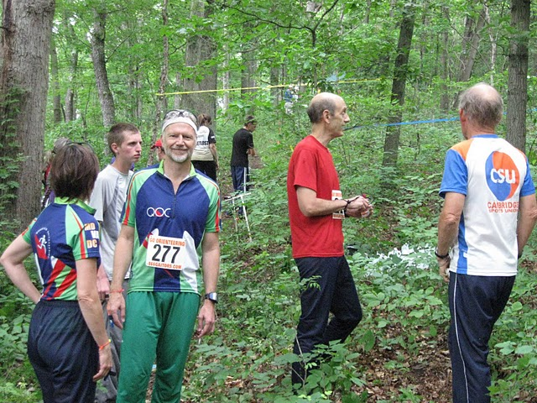
Deer Lakes Start
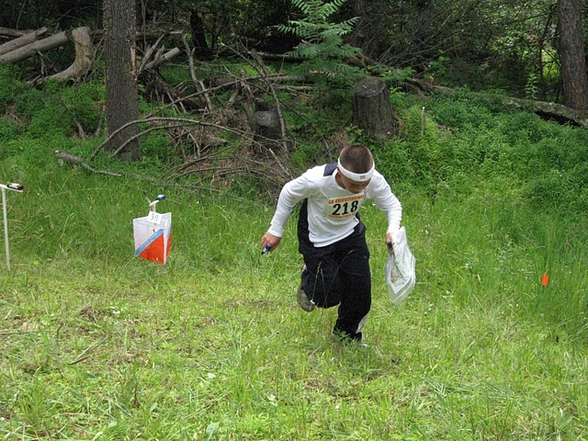
Keystone Finisher
A-Meet Acknowledgements
There are many people who have contributed their time and effort to putting on Keystone Capers. We gratefully acknowledge their assistance; without them, the event could not have been held. The following list attempts to identify them and what area they helped in; for all those who are not associated with WPOC, the club they belong to is shown.
Event Director | Jim Wolfe
Event Consultant | George Walker (WCOC)
Mapper | Jim Wolfe
Map Consultant | Fred Kruesi (DVOA)
Course Setter (Deer Lakes) | Mark Cornish (DVOA)
Course Setter (Keystone) | Tom Overbaugh (DVOA)
Course Consultant | George Minarik (BAOC)
Vetters | Mark Cornish (in charge at Deer Lakes)  Tom Overbaugh (in charge at Keystone)  Joe Logan, Ken Lappin (NEOOC), Randy Mitchell (NEOOC), Phil Martineau, Ralph Tolbert (DVOA), Hugh Macmullan (DVOA)
Registrar | Mary Frank (DVOA)
On Site Registration | Mary Frank, Al Sheaffer, Tick Sheaffer, Sherry Shank, Linda Gray
Start Crew | Janet Porter, chief (DVOA)  Denny Porter (DVOA), Ed Scott (DVOA), Rob Wilkison (DVOA), Tim Walsh (DVOA), Ed Niemann (DVOA), Phylis and Ron Wood (DVOA), Ray Wygonik, Tim Gilbert (QOC), Jim Trautmann, Mike Adametz, Bob Meyer (DVOA)

Finish Crew | Dan Barker (DVOA), Alexis Rzewski, Bob Boltz (NEOOC), Joe & Josh Weltner
e-Punch Management & Results | Sandy Fillebrown (DVOA)
Awards | Loretta Opila
Map and Packet Assembly | Tom Gray and Linda Gray
Safety Director | Loretta Opila
Instruction for Map Hikers | Dave Battista
Traffic Control | Tom Gray and Mike Ward
Control Pickup | Alexis Rzewski, Tim Gilbert, Mike Adametz, Dave Battista, Bob Boltz
Publicity | Alexis Rzewski
Refreshments | Giuseppina Mecchia
Baby Sitting | Jennifer Livingston
T-Shirt | Design: Gregory Gillis  Printing: Jennifer Livingston
Web pages and program | Jim Wolfe
We had several additional people helping in what might be called miscellaneous tasks. That is, they were filling where needed, a no less important contribution. These volunteers include
Gary Toward, Lyn Toward, Mark Frank (DVOA), Andy Strat (QOC)
WPOC would also like to thank various people and organizations who have contributed money or material to Keystone Capers. These include
Orienteering USA & Valerie Meyer who provided 30 e-punch controls at no cost.
Go Orienteering & Gale Teschendorf who provided the bib numbers at no cost.
re² & Jorgen Pedersen who pledged $250 to help with printing costs.
We also want to thank Kris Baker, manager of Keystone State Park, and Mike Dutch, manager of Deer Lakes Park for their on-going cooperation is putting this event together, and Mark Piantine and Lee Schmidt for providing EMT services.

