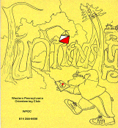
Jim Wolfe – President – (814) 255-6606
jlwolfe@atlanticbb.net
Bryon Roland – Vice-President – (724) 357-9328
bmann66@comcast.net
Jennifer Livingston – Secretary – (724) 770-1120
jenlivi@pobox.com
Club website – www.wpoc.org

WPOC Moves forward to Incorporation as a Non-Profit Group
Minutes from Organizational Meeting – November 9, 2008
Memberships represented: Battista, Johnstone, Livingston, Martineau, Maruccio, McElhinny, Opila, Roland, Rzewski, Shank, Torick, Unger, Unligil-Shaikh, Wolfe
Jim Wolfe called the meeting to order at 3:00 pm. As this was the organizational meeting, there were no previous minutes.
1. Election of Officers.
The following were elected to two-year terms. Each was nominated and seconded and elected by acclamation, as there were no other nominations.
President: Jim Wolfe
Vice President: Bryon Roland
Secretary: Jennifer Livingston
2. Election of non-officer Directors
The following were elected to one-year terms. Each was nominated and seconded and elected by acclamation, as there were no other nominations.
Non-Officer Directors: Barbara Johnstone and Alexis Rzewski
3. Jim Wolfe explained that the committee to apply for incorporation should be approved by the membership. The committee consisted of Jim Wolfe, Bryon Roland and Barbara Johnstone. Approval of the committee was moved and seconded and agreed to unanimously.
4. A financial report for 2008, through November 1, was provided. It showed the club to be financially stable. A tentative rough budget for 2009 was also provided for planning. The 2008 budget report and proposed 2009 budget are not attached here; the complete report and proposal will be sent to the membership in January after the fiscal year is over.
5. Discussion of 2009 meets.
Jim Wolfe outlined several goals he has set for 2009: 1) having 10 meets spaced about every 3 weeks in spring and fall; 2) reimbursing all meet director expenses; and 3) creating two new maps and revising two existing ones. A list of dates for possible meets was provided. There was some discussion about having or not having meets on Saturdays and during mid-summer. Bryon Roland volunteered to direct two of the meets.
6. Other Discussion
Several ideas were discussed, mostly regarding how to attract more participants or getting more club members to volunteer to help with the meets.
a. Alexis Rzewski suggested we try to get involved with schools to have classes of children participate in orienteering. These could be free events just to get the kids interested.
b. Alexis also suggested that we try to hold an event in Frick Park because so many people use it and because of its convenience for Pittsburghers. Jim Wolfe will look into making a map.
c. Mary McElhinny described how hard it is to get volunteers to help with the meets and asked for ideas on how to get more people to help. Jim Wolfe offered to provide some participation data to use to encourage more volunteers.
d. It was suggested that we may want to purchase caps for sale to club members in 2009, as we did with shirts in 2008. Jennifer Livingston will look into the cost of printing caps from the same place that supplied the shirts.
e. There was a question about the club's assets. Jim Wolfe reported that the club has three sets of controls (each with 40 or more) and sufficient punch cards. He noted that he would like to acquire more compasses to use as loaners - some have been broken or lost in the past year.
f. Jim Wolfe reported that the club purchased some orienteering brochures for distribution at promotional events, such as the Venture Outdoors Festival.
The meeting adjourned at 3:45 pm.

Club Statistics and Volunteering by Jim Wolfe
In 2008, WPOC sponsored 9 orienteering events; and by the end of the year, we had 51 members (23 family members and 28 individual members). This is a short report on attendance and activities of our members at the sponsored events. The Beaver Street-O is not counted in the report because it is primarily aimed at non-members.
An average of 14.4 members participated in each of the 8 regular events, with a high of 21 at National Orienteering Day at Deer Lakes and a low of 7 at the very rainy night-O at Stackhouse Park. Eleven members did not participate in any meets; many of these are people who became members at a fall 2007 meet and have not returned during 2008. Only one membership was associated with participating in all 8 meets - the Rzewski family. On average, each member attended 2.5 meets; that includes those who attended to go on a course, as well as those who attended only to help. On average, each member went out on one or more courses at 2.3 meets.
Twenty club members helped to put on this year's events. This included those who were meet directors, as well as those who volunteered to handle registration, start/finish, instruction, control pickup and vetting. Six different people directed meets in 2008, with one new meet director (Dave Battista). On average, each club member helped put on 1.4 meets this year by volunteering in some capacity. However, this number is misleading as 31 members (20 that came to meets and 11 that did not) never volunteered at all and half a dozen members volunteered 5 or more times.
RECOMMENDATION: If you are someone who goes out on courses at meets significantly more than the average (that is, more than 2.3) and volunteers to help at meets significantly less than the average (that is, less than 1.4), volunteer to help at a meet or two in 2009. No special skills are required and it takes only about 90 minutes of your time. The club will benefit and you will too as you learn a little more about how everything works. Some of you, I know, are limited in what time you can give or what days you can volunteer on. I'm sure Mary, our volunteer coordinator, can work with you on that. Just ask her at runoutside99@comcast.net
To all those who have volunteered to help the club, I want to say, "THANK YOU." Without you, the club could not function.

Event recaps:
Deer Lakes Park - September 14, 2008
It was an unusually hot and sticky day for September; but National Orienteering Day turned out to be a popular day for orienteering at Deer Lakes. We had a record number of starts, 74, with 114 participants. Many people did a second course. This was what we had hoped for; Jennifer designed the white, yellow, and orange courses to be relatively short and somewhat on the easy side to encourage particularly newcomers to try a second course. One orienteer, Joe Egan, even did three courses and another, Brian Ottinger, ran the same course twice. As usual, Alexis set the pace for both the orange and green courses. There were a lot of very positive comments about the courses; Jennifer did an excellent job in putting the courses together. She also made a string-O course that 19 younger children tried out.
For National Orienteering Day, we gave away a few frisbees that we acquired courtesy of the DVOA club and a few copies of ONA provided by USOF. And naturally, we gave little prizes to the kids who finished the string-O.
This was our first event at Deer Lakes Park; so it was a brand new map. Everyone seemed to like the map, even though many of the yellow areas were a bit faded because of a printing problem. No one complained about anything out of place.
Thanks to Jennnifer Livingston for directing the meet. Mary McElhinny, Laurie Opila, Barbara Johnstone, Joe Logan, Mike Ward and Bill Unger for running registration. Thanks to Dave Battista and Bryon Roland for handling start/finish. Thanks to Jennifer Livingston, Alexis Rzewski,and Laurie Opila for providing instruction. And, thanks to Dave Torick, Alexis Rzewski and Jim Hokanson for picking up the controls.
White Course 1.80 km 9 controls
Alex Habermann & Sam Gutkind |  | 18:44
David Waldeck (2) |  | 23:02
Zara, Molly, & Gilli |  | 24:05
Brian Stack & Keith Miller |  | 24:22
Vincent P. & David C. |  | 25:07
Patty Murtha |  | 28:15
Joe Barbish & Steven Kim |  | 29:06
Elijah & Dave Battista | WPOC | 29:10
Joseph Egan |  | 31:15
Ian Serbin & Laura Greenburg |  | 31:54
Luke Bittenbinder (2) |  | 32:00
Bree McCullough (2) |  | 37:46
Bobbi, Debbie, & Samuel |  | 38:38
Tom & Kelly Hahn |  | 43:30
Kurt & Carl Villock | WPOC | 48:10
Sam Okabayashi, Toby Junker, Sagar Kamath | Pack 274 | 55:58
Michael & Holden (5) | Pack 274 | 57:02
Roth Family (3) |  | 60:00
Miller & Spence (5) |  | 73:72
Yellow Course 2.55 km 10 controls
Keith Miller & Brian Stack |  | 18:01
Brian Ottinger (second time) |  | 21:20
Joe Barbish & Steven Kim |  | 22:35
Brian Ottinger (first time) |  | 23:09
Jan Waldeck (2) |  | 24:41
A. Flurie |  | 24:59
Ian Serbin & Laura Greenburg |  | 28:40
Joseph Egan |  | 30:50
Roger Stoffizeger |  | 32:05
Alex Habermann & Sam Gutkind |  | 32:50
Luca Rzewski | WPOC | 36:50
Jason Maruccio | WPOC | 42:15
Dave & Maggie Greer |  | 42:26
Gary Lohr | WPOC | 44:46
Zang Family (4) |  | 49:35
Don Lind (3) |  | 51:11
Janz Family (3) |  | 54:45
Sean Byers (4) |  | 54:57
Matt & Jess Simmons |  | 57:13
Vizino Family (6) |  | 58:45
Erica Henry |  | 60:45
Paul Sutcliffe (3) | WPOC | 61:23
Tom & Margy Kearney |  | 63:24
Unligil-Shaikh Family (4) | WPOC | 85:46
Mary Bates (2) |  | 86:14
Joe, Angela, & Joshua Weltner | WPOC | 128:34
Rick Szwaczkowski (2) |  | 128:34
Vincent P. & David C. One wrong punch, 20:52 |  | DSQ
Zara, Molly, & Gilli One missed punch, 45:40 |  | DSQ
Orange Course 3.75 km 10 controls
Alexis Rzewski | WPOC | 33:29
Karin & Anders Villwock | WPOC | 47:11
Tim Piper | WPOC | 53:50
Joseph Logan | WPOC | 57:30
Randy Fasenmyer |  | 57:47
Terry Gillis | WPOC | 60:57
Bill Unger | WPOC | 63:12
Steve & Nicole Schlotterbeck | WPOC | 63:18
Stephanie Martineau | WPOC | 74:15
Brian Ottinger |  | 75:00
Loretta Opila | WPOC | 78:22
Joseph Egan |  | 79:06
Mary McElhinny | WPOC | 79:30
Jason Maruccio | WPOC | 85:42
Ray Povirk |  | 89:35
Janz Family (2) |  | 122:57
Green Course 5.73 km 13 controls
Alexis Rzewski | WPOC | 59:41
Dave Battista | WPOC | 71:20
Bryon Roland | WPOC | 93:52
Jim Hokanson | WPOC | 104:10
Mark Desnoyer |  | 122:30
Phil Martineau | WPOC | 137:10
John Hinderliter | WPOC | 142:50
Frank Ferraro |  | 146:28
Jason Gray | WPOC | 154:14
Susan Moore & Dave Torick only 7 controls, 97:49 | WPOC | DNF

Some photos from the Deer Lake Event:
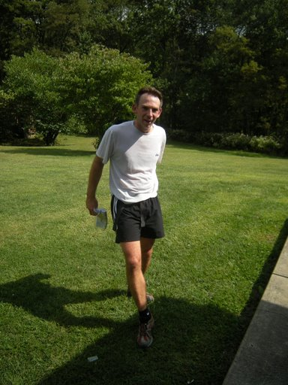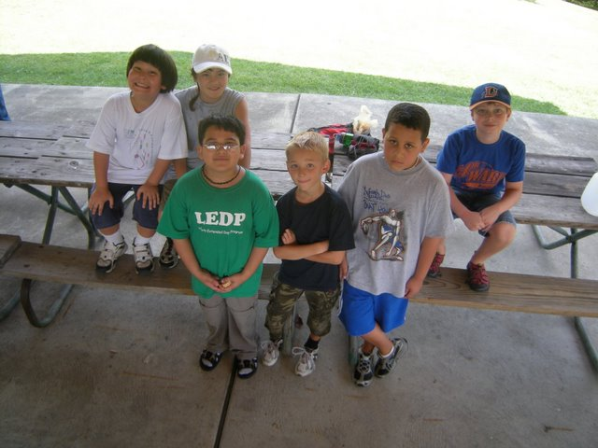
Dave B. finishing green
A group of Cub Scouts from Shadyside.

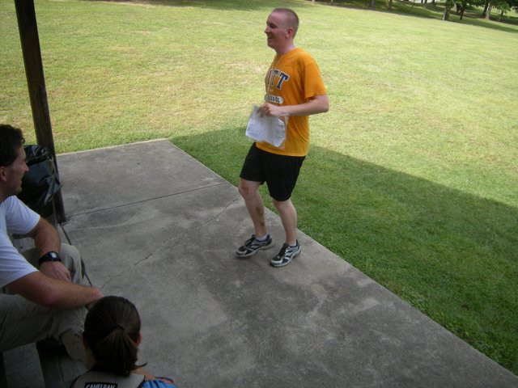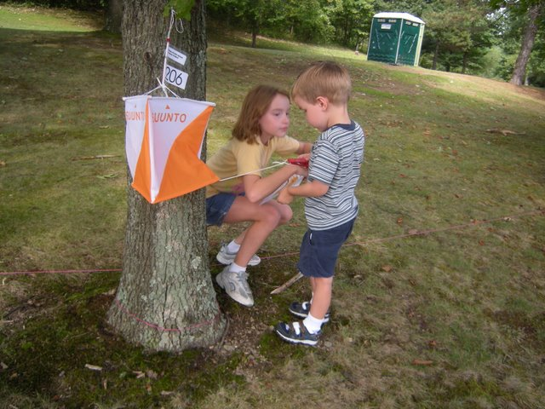
Jim H. finishes green.
String O

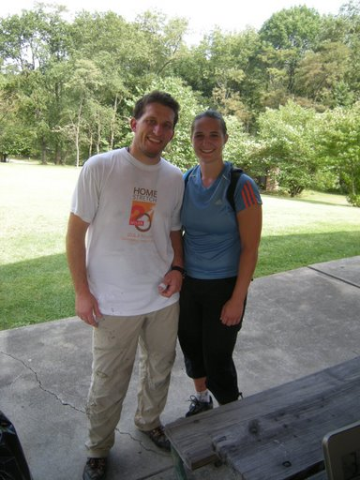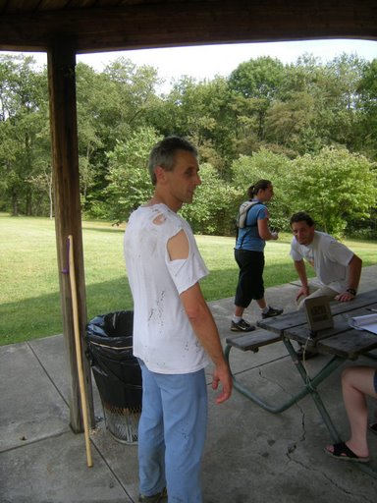
Susan and Dave T.
Time for Alexis to retire the shirt!

IUP Co-Op Recreational Park – October 19, 2008
It was an exceptionally nice day for orienteering - bright and sunny with temperatures in the 50's. We had a reasonable turnout; but the weather and the recent newspaper article about the club should have brought out a few more. Dave Battista was practicing for a rogaine so he ran all three courses. He even finished all the points on the score course in under 90 minutes - I thought I had made it tough enough that no one would be able to do that. (Bryon Roland would also probably have finished them all in 90 minutes if he had not miscalculated on the time.) The scoring for the score course had 6 controls worth 5 points each, 6 worth 10 points each and 6 worth 15 points each - a little variation to add some challenge to the route choices.
There were many positive comments about the courses and the forest - several groups brought back leaf souvenirs. Jim Wolfe was meet director. Thanks to Joe Logan, Bill Unger, Laurie Opila, and Mary McElhinny for running registration. Thanks to Bryon Roland for helping with start/finish. Thanks to Dave Battista, Bryon Roland, and Mary McElhinny for helping with control pickup. The next meet (last meet for 2008) will be at Pine Ridge Park on November 9 and will include a social get-together and a general membership meeting.
White Course 2.25 km 8 controls
Dave Battista | WPOC | 16:40
Jim & Patty Thomas |  | 44:51
Raykes |  | 52:30
Bill Unger | WPOC | 52:55
Teresa & Dylan Rinehart |  | 56:15
Joan Ferraro |  | 63:47
Team Carnahan |  | 73:36
Joe, Angela & Joshua Weltner | WPOC | 96:22
Jennifer Collins |  | 97:29
Yellow Course 3.22 km 10 controls
Dave Battista | WPOC | 26:25
Curt Mertz |  | 58:30
Gary Lohr | WPOC | 67:30
Sherry Shank | WPOC | 70:50
Ray Wygonik |  | 72:51
Joan Ferraro |  | 75:20
Sean Byers |  | 78:28
Chris Peters | WPOC | 82:15
Jim & Patty Thomas |  | 85:05
Rob Graham |  | 91:13
Luca Rzewski | WPOC | 105:09
Philip Reihl |  | 107:29
Ward Family | WPOC | 145:18
Aaron Blair |  | 149:14
Jan Reihl one wrong punch 109:10 |  | DSQ

Score Course 90 minutes 18 controls See paragraph for scoring 5 point penalty per minute late
Name | Club | Controls | Time | Penalty | Score
Dave Battista | WPOC | 18 | 88:16 | 0 | 180
Bryon Roland | WPOC | 17 | 79:35 | 0 | 165
Mary McElhinny | WPOC | 16 | 86:25 | 0 | 155
Curt Mertz |  | 12 | 87:45 | 0 | 120
Ray Wygonik |  | 10 | 85:10 | 0 | 110
Steve & Nicole Schlotterbeck | WPOC | 11 | 83:36 | 0 | 100
Joe Logan | WPOC | 11 | 84:17 | 0 | 100
Sherry Shank | WPOC | 7 | 91:16 | -5 | 55
Barbara Johnstone | WPOC | 5 | 79:10 | 0 | 40
Anne Hoover & Kathy Newquist | WPOC | 8 | 102:19 | -60 | 15
Paul & Kathy Sutcliffe | WPOC | 6 | 106:10 | -80 | -25
Frank Ferraro |  | 18 | 132:05 | -210 | -30

Pine Ridge Park - November 9, 2008
The temperature was only about 40 and it was rather windy; but it was still a pretty good day for orienteering. The newly fallen leaves made walking a bit slippery and required some attention because of the rocks under the leaves. The turnout was a bit low, especially for the white course; but we were starting an hour earlier than usual and I'm sure some thought it was too cold. We had a reasonable number try the yellow course which was deceptively short because it had a lot of climb; it also used some indistinct trails. We had a many participants try the score course which was quite spread out. Only Alexis managed to get all of the points on that course. The scoring for the score course had 7 controls worth 5 points each, 8 worth 10 points each and 4 worth 15 points each - a little variation to add some challenge to the route choices.
Dave Battista was meet director; he did an excellent job, especially considering this was his first attempt at meet directing. Thanks to Bill Unger, Laurie Opila, Barbara Johnstone, Bryon Roland and Mary McElhinny for running registration. Thanks to Dave Torick and Alexis Rzewski for helping with control pickup.
After the meet, we had our, now annual, get-together/spaghetti dinner. We also had our first general membership meeting.
White Course 2.07 km 7 controls
Luca Rzewski | WPOC | 26:46
Crew 50 |  | 34:37
Raykes |  | 56:08
Giuseppina Rzewski | WPOC | 56:19
Yellow Course 2.75 km 9 controls
Brian Ottinger |  | 45:06
Peters Family | WPOC | 59:11
Bill Unger | WPOC | 61:36
Stephanie Martineau | WPOC | 75:35
Jason Maruccio | WPOC | 81:30
Jen & Jason Livingston | WPOC | 90:48
CJK71 |  | 101:01
Crew 50 |  | 102:04
Kai Shaikh | WPOC | 135:45
Score Course 90 minutes 19 controls See paragraph for scoring 5 point penalty per minute late
Name | Club | Controls | Time | Penalty | Score
Alexis Rzewski | WPOC | 19 | 86:19 | 0 | 175
Eric Menendez |  | 17 | 87:18 | 0 | 150
Dan Beggs |  | 15 | 88:28 | 0 | 145
Bryon Roland | WPOC | 16 | 90:32 | 0 | 145
Mary McElhinny & Jason Maruccio | WPOC | 13 | 86:50 | 0 | 125
Joe Logan | WPOC | 11 | 86:42 | 0 | 110
Curtis Mertz |  | 11 | 81:05 | 0 | 105
Dave Torick | WPOC | 12 | 84:43 | 0 | 105
Tim Piper | WPOC | 11 | 88:35 | 0 | 105
Brian Ottinger |  | 12 | 94:55 | -20 | 95
Sherry Shank | WPOC | 8 | 89:42 | 0 | 90
Phil Martineau | WPOC | 7 | 82:03 | 0 | 60
Loretta Opila | WPOC | 8 | 113:35 | -115 | -50
Barbara Johnstone | WPOC | 8 | 121:22 | -155 | -90
John Popp |  | 11 | 186:45 | -480 | -370
2009 Events and 2009 Dues:
It is the goal of Jim Wolfe to have 10 meets in 2009! WOW! Check the WPOC website in 2009 for dates and details. We will need every club member to volunteer in 2009!
Please take a few minutes to pay your 2009 dues if you already have not done it.
WPOC has three levels of membership: individual membership ($10 per year),family membership ($15 per year - includes parents and kids), and junior membership ($5 per year for those 18 and under).
Feedback on the newsletter should be directed to Mary at runoutside99@comcast.net

