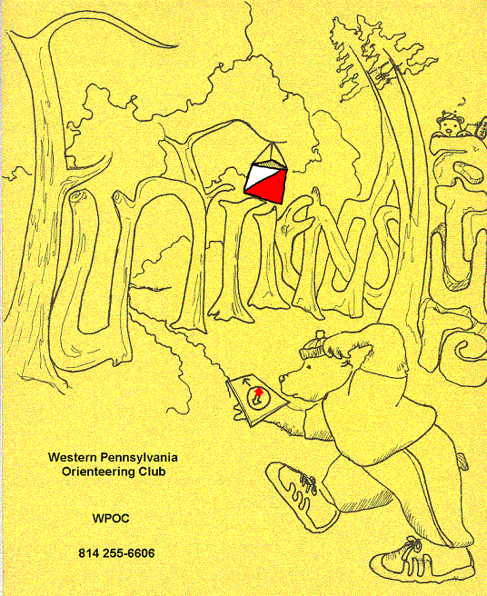
Jim Wolfe – President – (814) 255-6606 (nights)
(724) 357-6104 (days)
jlwolfe@atlanticbb.net
Bryon Roland – Vice-President – (724) 357-9328
Bman66@adelphia.net
Jennifer Livingston – Secretary – (724) 770-1120

Welcome to the first installment of the WPOC newsletter. The goal of the newsletter will be to keep club members and future club members informed of club meets, meet results and future plans of the club. Hopefully, the newsletter will turn into a group effort with everyone contributing his or her ideas. The idea of a newsletter came about during a brainstorming session after the Camp Seph Mack event on April 9, 2006 when a group was discussing how things were going with the club and what help was needed in any and all areas of the running of the club, growing the club and trying to keep everyone informed of events. So we all hope your enjoy the newsletter! The goal is to have an electronic copy of the newsletter every couple of months. It will be filled with club news, event summary, training and nutrition ideas, orienteering tips and member feedback on WPOC events or other orienteering events that members participate.

The first meet of 2006 was held at Pine Ridge Park on March 26, 2006. The meet director was Jim Wolfe. It was cold day for the volunteers but it was a nice temperature to be out running in the woods and we should thank Jim for the great hill work. As Jim put it, “We had an extraordinary turnout, our largest event ever in terms of number of starts.” The club also picked up 4 new members; a big WPOC welcome goes out to Phil and Stephanie Martineau, Bill Croyle, and Frances Irwin. We hope you enjoyed yourselves! Complete meet results can be viewed on line at wpoc.org. Thanks to Sally O'Donnell and Laurie Opila for keeping registration going smoothly. Thanks to Jerry Agin and John Hartman for holding down the start. Thanks to Lenny Lewis who stepped forward in time of need and covered the finish. And thanks to Mary McElhinny, Bryon Roland and John Hartman for picking up the controls.

The second spring meet was held at Camp Seph Mack event on April 9, 2006. The meet director was Al Sheaffer and he put together a fun, challenging event. Great news for the club, according to Jim, “ We had another excellent turnout; in fact the number of starts beat our old record which was set only two weeks earlier.” The club added two new members, welcome Karen Gracy and Wayne Richter. Thanks to Laurie Opila, Barbara Johnstone, John Hartman and one of the Penn State students (we didn't catch her name) for keeping registration going smoothly. Thanks to Al Sheaffer, Mary McElhinny, Bryon Roland and John Hartman for picking up the controls, Al also put out nearly all of the controls. Here are the results:
White Course 2.43 km 67 m climbs 9 controls
Andrew & Michelle |  | 33:30
Donald Wheeler group |  | 41:28
Shane Boone | BSA | 50:09
Ryan McQueen | BSA | 65:38
Wayne & Tyler Richter | WPOC | 92:35
Donald Wheeler alone |  | DNF
Yellow Course 3.14 km 110 m climbs 10 controls
Lenny Lewis & Zech Anderson | WPOC | 33:43
John Davis |  | 54:00
Ashley & Dave | PSU | 61:00
Zach Teeter & Brenden McCann | PSU | 61:27
Keith Bowman | PSU | 65:23
Frank Litavish | PSU | 70:12
Brent Berezansky & Josh Kuhstos | PSU | 71:23
Troop 622 (Adam Steinbring) | BSA | 73:46
Shane Stoehr & Colin Lennox | PSU | 74:48
Tammy Cash | WPOC | 87:52
Eric Steinbring | BSA | 89:21
Smell the Roses | WPOC | 89:25
Colker Family |  | 94:14
Amanda & Emily | PSU | 96:00
Mark Malagodi |  | 97:55
Karen Gracy | WPOC | 101:15
Wayne & Tyler Richter | WPOC | 116:52
Alex Tost |  | 120:43
Austin Davis & Scott & Cliff McDivitt |  | 122:43
William Croyle | WPOC | 143:35

Orange Course 4.19 km 140 m climb 12 controls
Bryon Roland | WPOC | 36:12
Kristaps Tamuzs | NEOOC | 37:37
Alexis Rzewski | WPOC | 39:32
John Hartman | WPOC | 43:53
Jason Gray | WPOC | 57:10
Steve & Toby | PSU | 62:10
Mary McElhinny | WPOC | 67:13
Michelle & Andrew |  | 70:00
John Davis |  | 74:17
Chris Muellen | ROTC | 82:12
Green Course 5.12 km 146 m climb 13 controls
Toby Angove |  | 38:35
Bryon Roland | WPOC | 45:30
Kristapz Tamuzs | NEOOC | 45:43
Alexis Rzewski | WPOC | 49:45
Chris Peters |  | 61:02
Jason Gray | WPOC | 66:30
John Hartman | WPOC | 68:30
Mary McElhinny | WPOC | 68:50
Joseph Woodley | ROTC | 95:50
Kate Fissell |  | 141:20

Some of the members of the WPOC have a few ideas for additions to the WPOC schedule and we would love members and non-member’s feedback of a few issues so please drop me an email with input and/or additional ideas. (runoutside99@adelphia.net)
The following are a few of the ideas:
- A night, late summer, or early fall O-Meet or Rogaine
- Regularly scheduled club meetings, and ideas on when and where to have meetings.
- Banquet for WPOC members and ideas on when and where to hold banquet.
- Newsletter – Beneficial, yes or no, electronic or mailed copy?
- Any interest in a red or blue course?

Upcoming WPOC Events:
- May 21, 2006 – Sunday – University Farm -11:00 am to 2:00 pm – White, Yellow, Orange and Green – meet Director, Jim Wolfe – Directions: To reach the University Farm, follow Rt. 422, 286, or 954 into downtown Indiana, PA (to Philadelphia Street). Take 9th Street north (North Route 954) for about 1.5 miles to the IUP Co-Op Recreational Park, Fulton Run entrance. Make a sharp left into the entrance. Follow the red and white Orienteering signs to parking.
- June 17, 2006 – Saturday – Blue Spruce Park – 11:00 am to 2:00 pm – White, Yellow, Orange and Green – meet Director, Bryon Roland – Directions: To reach Blue Spruce Park from US 119, take the PA 110 West exit northeast of Indiana. Follow PA 110 west 3.4 miles to the entrance of the park (Blue Spruce Park Road). Follow the orange and white Orienteering signs to parking. Alternatively, take any road into downtown Indiana then follow PA 954 north (9th Street) for 0.5 miles. Turn north on Martin Road (route TR 488) and go 3.5 miles to Blue Spruce Park Road.

?? Question of the Newsletter – What is the origin of the term Rogaine?

For those WPOC members that love orienteering and travel, listed below are some nearby Events and Club addresses for when you want to have a fun weekend:
- QOC - Quantico Orienteering Club serving Virginia, Maryland and District of Columbia. http://qoc.us.orienteering.org/
  - Sunday, May 7, 2006 – University of Maryland (Sprint)
  - Sunday, May 14, 2006 – Fountainhead, VA
  - Sunday, May 21, 2006 – Annapolis, MD (Sprint)
  - Sunday, June 4, 2006 – Mont Alto, PA
  - Sunday, June 11, 2006 – Jug Bay
- ROC - Rochester Orienteering Club – New York http://roc.us.orienteering.org
  - Saturday and Sunday, June 10 and 11th, 2006 – North American Rogaine Championship Allegany State Park, Rogaine. 6, 12, and 24-hour categories. (Several club members are planning on doing the 24-hour event!)

- DVOA – The Delaware Valley Orienteering Association – www.dvoa.us.orienteering.org
  - Saturday, May 6, 2006 – French Creek Central – WYO/Score-O
  - Sunday, May 7, 2006 – French Creek Central – WYOBrGR
  - Sunday, May 14, 2006 – Iron Hill – WYOBrGR
  - Sunday, May 21, 2006 – Hickory Run – All
  - Sunday, June 4, 2006 – Valley Forge Fatlands – WYOBrGR
  - Sunday, June 11, 2006 – Quail Hill - WYOBrGR
  - Saturday, June 17, 2006 – Myrick Center – relay
- NEOCC- North Eastern Ohio Orienteering Club – http://neooc.home.att.net/
  - Saturday, May 6, 2006 – CVNP – Sprint –O
  - Saturday, May 27, 2006 – Hinckley Johnson’s Picnic Area – Cross Country
  - Saturday, June 17, 2006 – CVNP Happy Days Visitor Center – 6 Hour Rogaine
  - Sunday, June 18, 2006 – Cuyahoga Falls Cuyahoga Falls Natatorium – City Quest (urban Rogaine).
- SVO – Susquehanna Valley Orienteering, Near York, PA –
http://d-domains.net/svo/
  - Sunday, April 23 – Lancaster County Central Park Scout Event – W, Y, O and Score-O
  - Sunday, May 7, 2006 – W, Y, O, G, R
  - Saturday and Sunday, May 27 & 28 – Michaux Rogaine – 6, 12, or 24 hour Rogaine
  - Sunday, June 4 – Mont Alto – Dual meet with QOC.

Feed back concerning newsletter should be directed to Mary McElhinny at runoutside99@adelphia.net. Please be gentle, I was volunteered for the job and this is my first attempt

Answer: The first official Rogaine took place in Australia in the 1970’s and the term comes from the combination of the names of the 3 co-founders; Rod Phillips (Ro), Gail Davis (gai) and Neil Phillips (Ne).

