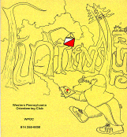
Jim Wolfe – President – (814) 255-6606
jlwolfe@atlanticbb.net
Bryon Roland – Vice-President – (724) 357-9328
bmann66@comcast.net
Jennifer Livingston – Secretary – (724) 770-1120
jen.livingston@pobox.com
Club website – www.wpoc.org

2009 Events, Volunteering and 2009 Dues:
We have 8 remaining meets scheduled for 2009. The events are as follows:
- Saturday, May 9, 2009 – Camp Twin Echo – New Map
- Sunday, May 31, 2009 – Stackhouse Park – Revised Map
- Sunday, June 14, 2009 – Boyce Park
- Sunday, August 16, 2009 – Keystone State Park – New Map
- Sunday, September 20, 2009 – Blue Spruce Park – National Orienteering Day
- Sunday, October 4, 2009 – Deer Lakes Park
- Saturday, October 24, 2009 – Camp Seph Mack – Night Meet
- Sunday, November 8, 2009 – Pine Ridge Park – Pine Lodge Party
Please check the website for the specifics of each event.

We will need every club member to volunteer in 2009 to comfortably staff the remaining schedule. Remember volunteering takes no special skills and only requires about 1.5 to 2 hours help on the day of the meet and you can still go out on the course. Every club member should make it their personal goal to volunteer for at least one meet this year.

Please take a few minutes to pay your 2009 dues if you already have not done it. Membership renewals information can be found on the WPOC website. Membership renewal can also be taken care of at the next meet you attend.

WPOC has three levels of membership: individual membership ($10 per year), family membership ($15 per year - includes parents and kids), and junior membership ($5 per year for those 18 and under).

We love getting new members so join Today!

WPOC Flyers for 2009 Meets
On the WPOC website (www.wpoc.org) under the Flyer bullet on the left of the website there are flyers for every WPOC event for 2009. The flyers contain information and directions for every meet and are they are great to print up and disperse at your local meeting places and to help promote the club. We are always looking for new club members and we want to do all we can to promote our sport and club. A happy and healthy club is a growing club.

WPOC Board of Directors Notes:
To all WPOC members:
In March, the Board of Directors agreed on two policies that mostly apply to meet directors, but could apply to any member. The first is a reimbursement policy and is meant to apply to a club member who needs to purchase something or has to pay for something while doing club business. It covers costs for meet directors, course setters, vetters, mappers, and anyone making a presentation of some sort for the club.
You can read this policy and see the associated reimbursement form on www.wpoc.org
Just go to "Club Documents" and look at "WPOC Policies" and "Reimbursement".

The second policy is meant to cover situations in which some organization outside WPOC pays a stipend or offers an honorarium to a club member for putting on a presentation or a workshop. This policy is also available at "WPOC Policies".

WPOC Board of Directors:
- Jim Wolfe
- Bryon Roland
- Jennifer Livingston
- Barbara Johnstone
- Alexis Rzewski

WPOC Travels to an A Meet: Ran it Granite (by J. Wolfe)
On March 27-29, the Quantico Orienteering Club put on an A-meet (a national event) near Baltimore; they called it Ran It Granite because of the small town of Granite located nearby. WPOC was represented by six club members. There were about 350 orienteers from around the country and from several foreign countries at the event. This is the first A-meet that so many WPOC club members have attended; collectively, we did fairly well.
Alexis Rzewski was the only one of us to run in the sprint races on Friday. He placed well in the two races he ran. He was 29th of 144 with a time of 18:14 in the first race (winning time 13:24). He was 23rd of 123 with a time of 15:12 in the second race (winning time 12:11).
On Saturday, the competition was with middle distances. Luca Rzewski was competing in M-12 on the 2.7 km White course. Stephanie Martineau was competing in F60+ on the 3.3 km Brown course. Jim Wolfe was competing in M60+ on the 4.0 km Green-X course. Alexis Rzewski and Phil Martineau were competing in M45+ and Dave Battista was competing in M40+; all were on the 4.7 km Red-X course. At national competitions, Green and Red are often two courses each because there are so many competitors in the classes associated with these courses.
On Sunday, the competition was with classic (long) distances. Luca was on a 2.5 km White; Stephanie chose not to compete; Jim was on a 5.7 km Green-X; and Alexis, Phil and Dave were all on a 8.1 km Red-X.
Luca finished the two days 2nd in the M-12 class. He was also 5th of the 10 who competed on White. His combined time was 56:13 for the two days; the fastest on White in M-12 was 55:39 and the fastest overall on White was 44:03. So, Luca only missed first place in his class by 34 seconds.
Stephanie was 3rd in F60+ after the first day with a time of 1:43:51 but did not place overall because she did not start on Sunday.
Jim finished the two days 15th of 22 in the M60+ class. He was also 41st of the 69 who competed on Green-X. His combined time was 2:21:19 for the two days; the fastest on Green-X in M60+ was 1:27:16 and the fastest overall on Green-X was 1:14:16.
Alexis finished the two days 7th of 28 in the M45+ class. He was also 13th of the 48 who competed on Red-X. His combined time was 2:08:07 for the two days. Dave finished the two days 3rd of 5 in the M40+ class. He was also 35th among all who competed on Red-X; his combined time was 3:22:02 for the two days. Phil finished the two days 21st of 28 in the M45+ class. He was 37th among all who competed on Red-X; his combined time was 3:55:10 for the two days. The fastest two-day time on Red-X in M45+ was 1:50:48; the fastest two-day time on Red-X in M40+ was 1:57:49. The fastest overall on Red-X was 1:43:11.
Note: Phil was not competing in the most advantageous class. Rumor has it that he chose M45+ so he could compete with his brother who was also at the meet. He did beat his brother, by four minutes. You can check out the results in more detail or look at the routes that some competitors used at http://qocameet.org
Jim Wolfe at finish of A-meet
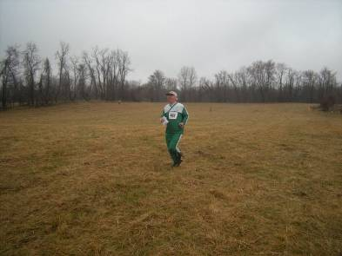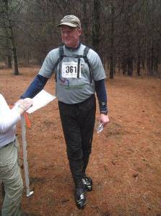
Phil Martineau at the A-meet

WPOC Face Book
Alexis Rzewski has created a Face Book page and if anyone wants to join the FB group, just look for the group under the title “Western Pennsylvania Orienteering Club”.
Alexis is also the responsible party that takes all the great photos at the meets.

Event recaps:
IUP Co-Op Recreational Park – March 22, 2009
It was almost an ideal day for orienteering - temperature about 50, overcast with very little wind. Naturally, visibility was excellent because Spring had barely sprung. The weather may have had something to do with it; but the turnout was very good and everyone seemed to have a good time. We even added new members-welcome to Michael & Carol Adametz, Ray Wygonik, Frank Ferraro, and Curt Mertz.
As usual, the Rzewskis set the pace for the courses; Luca burned up the White course while Alexis finished the Score way ahead of the time limit. A couple participants on the Yellow course thought one of the controls was misplaced; but the check during control pickup proved it to be in the correct location. Many participants on the Yellow course encountered Candy Land scattered about on the course - due to some other group using part of White's Woods during the day.
Bryon Roland was meet director; he designed some very good courses and challenged most of those on the Score course. Thanks to Joe Logan, Laurie Opila, Barbara Johnstone, Jennifer Livingstone, and Mary McElhinny for running registration. Thanks to Mike Ward and Bryon Roland for handling start/finish. Thanks to Alexis & Luca Rzewski and Dave Battista for helping with control pick up.
White Course 1.9 km 8 controls
Luca Rzewski | WPOC | 25:49
Tara, Brooke, Jeffery & Chris (4) | Crew 50 | 40:13
The Finegans (4) |  | 40:15
Giuseppina Rzewski (2) | WPOC | 44:38
Danielle Pisarcik |  | 45:22
Nathan Tyger (2) |  | 48:45
Anton Sulkosky |  | 52:00
McCoy (4) |  | 69:30
Walter Schroth (3) |  | 70:00
Sandy Augustine & Janice Shields (2) | WPOC | 72:32
Raykes Family (4) |  | 75:30
T. Kaveney & L. Grant (2) | WPOC | 82:02
Troop 50 RU Boys (7) |  | 82:02
Dylan and Pat (2) Missed one control 97:15 |  | DSQ
Yellow Course 3.5 km 9 controls
Mary McElhinny | WPOC | 39:58
Lenny Lewis | Crew 50 | 44:31
The Peters (4) |  | 45:30
Michael Adametz | WPOC | 51:50
Jennifer Livingston | WPOC | 58:24
Brad, Tara, Brooke, Andrew & Lenny (5) | Crew 50 | 62:08
Al Sheaffer | WPOC | 62:48
Byers (3) |  | 70:55
Luca Rzewski | WPOC | 76:35
Crew 11 Youth (4) |  | 77:10
Barbara Johnstone | WPOC | 82:13
Crew 11 Adult (3) |  | 88:10
Linda Gray (2) |  | 117:10
Terry Gillis & Troop 344 (7) | WPOC | 128:30
T. Rinehart did not get an official start; completed course |  | DNS
Michael Ward found only 3 controls; 162:30 | WPOC | DSQ
Score Course 90 minutes 17 controls 10 points per control 10 point penalty per minute late
Name | Club | Controls | Time | Penalty | Score
Alexis Rzewski | WPOC | 17 | 64:00 | 0 | 170
Fedya Kleshchev |  | 15 | 82:28 | 0 | 150
Diane & Mike Lorenz | WPOC | 14 | 85:05 | 0 | 140
Mary McElhinney | WPOC | 14 | 86:40 | 0 | 140
Dave Battista | WPOC | 14 | 88:59 | 0 | 140
Dan Beggs |  | 12 | 90:30 | 0 | 120
Curtis Mertz | WPOC | 11 | 84:00 | 0 | 110
Ethan Goldblum |  | 11 | 84:45 | 0 | 110
Francesca Fenzi & Eli Fatsi |  | 10 | 88:00 | 0 | 100
Joe Logan | WPOC | 11 | 91:59 | -10 | 100
Ray Wygonik | WPOC | 13 | 94:03 | -40 | 90
Chris Gillis (2) | WPOC | 4 | 86:34 | 0 | 40
Sherry Shank | WPOC | 3 | 80:00 | 0 | 30
Manoj Dayaram |  | 5 | 117:03 | -270 | -220
Frank Ferraro | WPOC | 17 | 139:20 | -490 | -320
Hartwood Acres – April 18, 2009
It was bright sunny day with temperatures in the 70's. We had an excellent turn-out with the second highest number of starts ever, 70, and the highest number of starts on the White course ever, 25. We had a few people do a second course; but many of them found one course long enough. There were a lot of positive comments about the courses; no one got lost; everyone seemed to have a good time. Some even got a chance to view some unexpected wildlife with a hawk sighting and a couple of snake sightings (non-poisonous ones).
WPOC membership for 2009 now stands at 43. We had one new member join at this meet; welcome to Richard Szwaczkowski. In the results listing below where it is not apparent how many were in each group, there is a number in parentheses after the name to show the group size. Our next meet will be on May 9 at Camp Twin Echo; it will be our first event in that area.
Thanks to Laurie Opila, Joe Logan, Dave Battista, Terry Gillis, and Bill Unger for running registration. Thanks to Mary McElhinny and Bryon Roland for handling start/finish. Thanks to Laurie Opila for providing instruction. And, thanks to Luca & Alexis Rzewski, Bill Unger, Phil Martineau and Joe Logan for picking up the controls.
White Course 2.04 km 9 controls
Eric Dzugan |  | 35:25
Jon Kane (3) |  | 37:02
Dan Stoffel (2) |  | 44:00
Phil Breidenback (2) |  | 45:02
Tyler C. & Ted Brickner (6) | 4-H | 45:59
Trish Kosmak (2) |  | 49:10
Louise Varner & Sarah Adalbert (3) | 4-H | 49:59
Steve Awodey (3) |  | 50:20
Jamie, Jim & Andy Brandon |  | 54:20
Sara, Tyler Cubarney & Sue | 4-H | 56:07
Mike Helbling (2) |  | 59:25
Cris Ruffolo (5) |  | 61:20
Theresa Rudolph (2) |  | 64:30
Fabers (5) |  | 65:20
Group 3 (2) | Troop 482 | 67:49
Group 4 (2) | Troop 482 | 68:20
Group 1 (2) | Troop 482 | 68:30
Battistas (5) | WPOC | 68:45
Group 2 (2) | Troop 482 | 70:30
Spence & Miller (3) |  | 72:45
Kim & Sue McCoy |  | 75:02
Martin Erson (4) | WPOC | 77:05
Woolstrum (3) |  | 84:05
Geoff Hogate (7) | Pack 139 | 154:20
Beth, Karen & Melissa one wrong punch 60:04 | WPOC | DSQ
Yellow Course 3.48 km 10 controls
Susan & Dany |  | 46:35
Bill Unger | WPOC | 49:05
Eric Dzugan |  | 49:35
Ray Wygonik (2) | WPOC | 50:30
Kyle Erson (2) | WPOC | 52:10
Daniel Stoffman (2) |  | 65:30
Phil Breidenback (2) |  | 66:00
Mike & Miha Bass |  | 67:26
Timothee Doutriaux & Benjamin Ettori |  | 69:36
Michael Helbling (2) |  | 70:17
Nelms-Vizino-2 (5) | WPOC | 71:44
Nelms-Vizino-1 (5) | WPOC | 72:50
Dan Ruby |  | 79:00
Smell the Roses (2) | WPOC | 90:25
Tom & Margy Kearney |  | 103:20
Venture Crew 23 |  | 109:56
Mary Bates (2) |  | 113:14
Tom Kaveney (2) | WPOC | 124:30
Thomas Schaaf (4) |  | 124:45
Rich (3) |  | 139:30
Ray (3) |  | 141:32
Chuck (3) |  | 147:50
Orange Course 5.00 km 11 controls
Mary McElhinny & Danielle | WPOC | 80:35
Terry Gillis | WPOC | 80:54
Scott Gillis | WPOC | 81:27
Ray Wygonik | WPOC | 93:34
Samarth Bhargava (2) |  | 114:12
Dan Ruby |  | 132:52
Greer (4) |  | 135:08
Chris & Corey |  | 138:17
Luca Rzewski, Jan Reihl & Philip D | WPOC | 140:50
Koenig & Walters (3) |  | 148:27
Ken Janowitz (2) |  | 150:04
Nader Shaikh (6) lost punch card 145:04 | WPOC | DNF
Green Course 6.36 km 15 controls
Alexis Rzewski | WPOC | 51:45
Bryon Roland | WPOC | 64:00
Jerome Pesenti |  | 64:12
Eric Sutterlin | MNOC | 77:02
Ethan Goldblum |  | 89:01
Frank Ferraro | WPOC | 103:10
Joe Logan | WPOC | 104:35
Phil Martineau | WPOC | 114:30
Jason Gray & John Dinardo | WPOC | 132:00
Frances & Keith Irvin |  | 156:13
Erik Kulick |  | 175:03
Photos Taken by Alexis at Hartwood Acres
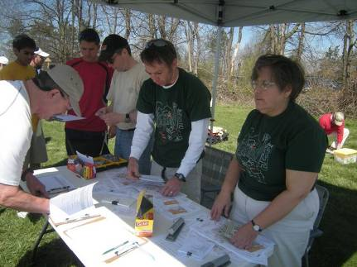
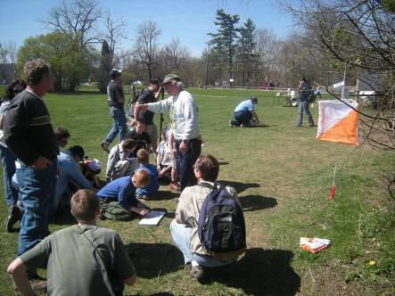

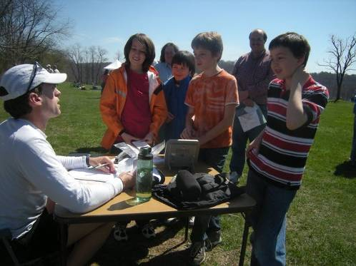
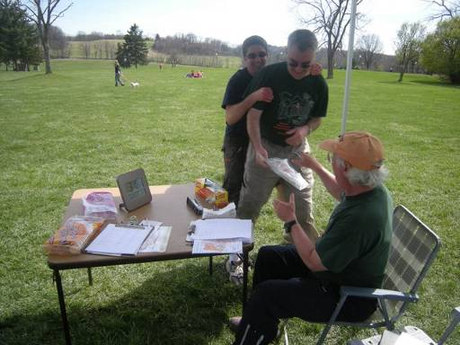
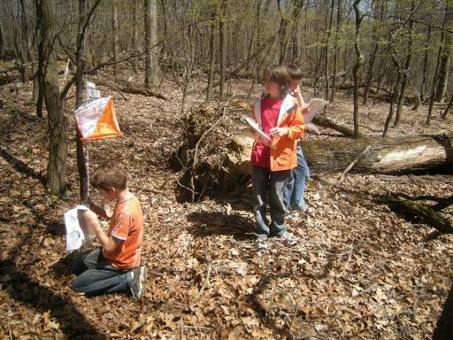
Feedback on the newsletter should be directed to Mary at runoutside99@comcast.net

