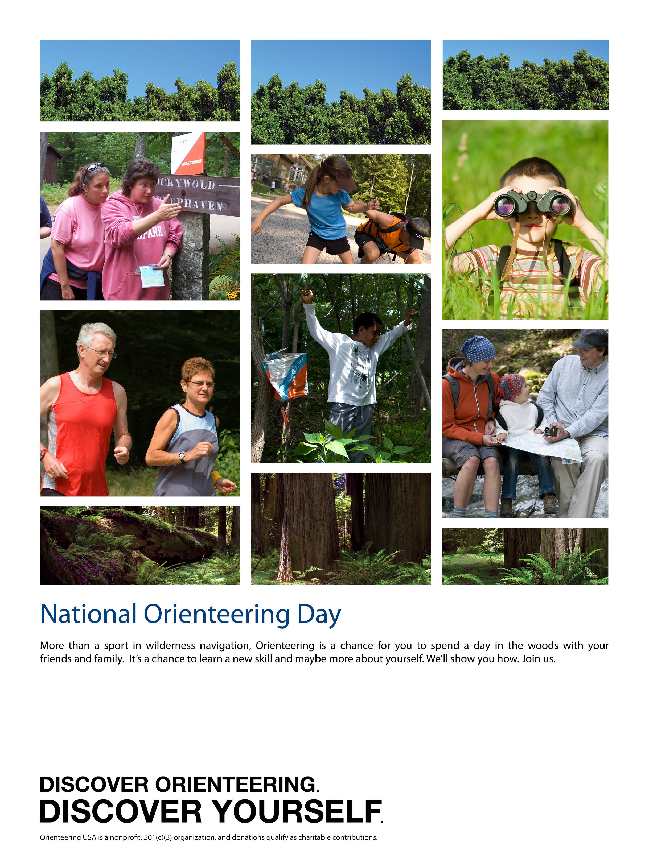

Event: Orienteering at Keystone State Park
Date/Time: September 20, 2015 Registration and starting from 11 am to 2 pm
Location: Keystone State Park is about three miles south east of New Alexandria
For more information including driving directions: Go to www.wpoc.org or call Jim Wolfe at 814 255-6606

